

Southern California Edison
CS Re-Platform Project

CIM-CS-15 - Manage Customer Segmentation & Campaign Management

Customer Interaction Management
Business Process Design
Version 1.1

Table of Contents
1 Business Process Overview 5
1.1 Current Pain Points for Southern California Edison 5
1.2 Responsible Parties 6
1.3 Document Control 6
1.4 Terminology 6
2 Business Process Design 8
2.1 General User Navigation 8
2.2 Contacts 11
2.2.1 Profile Dashboard 11
2.2.2 Contacts 12
2.3 Segmentation 21
2.3.1 Building Blocks 25
2.3.2 Import of Contacts 26
2.3.3 Target Groups 26
2.4 Content Studio 31
2.4.1 Sender Profile Settings 32
2.4.3 Dynamic attributes for header and body template 34
2.4.1 Upload an external Layout 37
2.4.2 Test layout 38
2.5 Campaign Management 38
2.5.1 Suppression Rules 44
2.6 Marketing Lead Management 44
2.6.1 Marketing Lead Stage 45
2.6.2 Marketing Lead transfer to SAP C4C 45
2.7 Analytics 46
2.7.1 Analytics in SAP Marketing Cloud 46
2.7.2 SAP Analytics Cloud 48
2.8 Process / Performance Improvement 49
2.9 Prerequisites and Inputs 49
2.10 General Assumptions 50
2.11 Process Flows 50
2.11.1 Segmentation and Campaign Management 50
2.11.2 Marketing Lead Management 52
2.12 3rd Party and SCE Legacy System Integrations 54
2.13 Data Elements 54
2.13.1 Source Systems and Data Volumes 57
2.14 SAP Marketing Cloud Integration 58
2.14.1 Processes 58
2.14.2 SAP Marketing Cloud Views 58
2.15 Exception Management Requirements 58
2.16 Process Risks and Mitigation 59
2.17 Key Performance Indicators 59
2.17.1 Key Metric Definition 59
3 Controls, Regulatory Rules, and Security 60
3.1 Security Considerations 61
3.2 Custom Program/Transaction Codes 62
3.3 Custom Table/Transaction Codes 62
3.4 Data Criticality and Cybersecurity Baseline Risks 62
4 Technical Considerations 64
4.1 RICEF-W Assessment 64
4.1.1 Reports 64
4.1.2 Interfaces 64
4.1.3 Conversion 64
4.1.4 Extension/Enhancements 64
4.1.5 Forms 64
4.1.6 Workflows 65
4.2 IDEX Considerations 65
4.3 Production System Cut-over Considerations 65
4.4 Other Considerations 65
5 Change Management 66
5.1 Change Impacts 66
6 Requirements 71

This page intentionally left blank

Business Process Overview

As a part of the CSRP project, SCE is incorporating SAP Marketing Cloud as part of their Customer Relationship platform.
SAP Marketing Cloud will be utilized by Customer Programs and Services (CP&S), and the Business Customer Division (BCD).

This document will provide an overview of the key functionality that will be used by SCE for Segmentation and Campaign Management requirements. Based on the key functions identified which will be performed:
- Contacts and Profiles
- Segmentation
- Content Studio
- Campaign Management
- Lead Management

SAP Marketing Cloud is based on two main objects:
- Contacts: Business Partners (Accounts, Contacts, and Account Contacts) are called Contacts as a general term in SAP Marketing Cloud due to represent an entity who SCE will interact to. Accounts refer to the organization BP while the account contact represents the person with a BUR001 relationship.
- Interactions: Transactions (Activities and Leads) are created in SAP Marketing Cloud as an Interaction.

The information available in SAP Marketing Cloud will be replicated from SAP’s C4C production system, which will receive all data from the S/4 HANA production system. All Contacts and Transactions that are created or updated in S/4 HANA will be replicated in SAP Marketing Cloud.

Current Pain Points for Southern California Edison
- Currently SCE does not hold any object with centralized information to store Customer Information.
- A general overview of the Customer’s Interactions per channel is not available to create effective target groups and campaigns.
- Duplication of Business Partners which require consolidation in order to achieve a realistic view of customer information.
- The current system currently has bad/obsolete data regarding customer Contact perference information. This is not maintained in the current CSS system.
  - Customer Contact information (email,SMS, TTY and mailing addresses) and notification preferences are stored in multiple systems today which are not integrated. This can result in non-compliance with TCPA and CAN-SPAM laws and customer dissatisfactoin.
  - Most customer information is not validated on a regular basis to ensure that there is good contact data for electricity related communications (e.g., pending disconnect), safety (e.g., outage alerts), program alerts (e.g., DR events) and identification processes (e.g., caller ID in IVR).

Responsible Parties
Contact | Contact Person
Southern California Edison Business Process Owner | Megan Mao
Southern California Edison Lead | Christine Evans
HCL SAP Marketing Cloud Functional Lead | Naveen Kuchikulla
Solution Architect | Pedro Ferreira da Costa
Front Office or Back Office Lead | Christine Evans
Subject Matter Experts | Sherri Lewis  Ernesto Valle  Janine Aumont  Ken Reichley  Stacy Brennan  Erikka Foy  Giovanni Castro  Danielle Manzano  Eva Flores
Key User Group | Business Customer Division (BCD)  Customer Programs and Services (CP&S)  Customer Service Operations Division (CSOD)

Document Control
Version | Description of Change | Date | Author
1.0 | Creation of Initial Version | 06/12/2018 | Beatriz Alonso  Caique Escaler
1.1 | Updated based on the feedback provided during the walkthrough on July 16th. | 07/16/2018 | Beatriz Alonso.

Terminology
Term/Acronym | Definition and SAP Equivalent (if applicable)
SCE | Southern California Edison
Customer | Any entity with a relationship with SCE. This term is usually used in reference to customers (both individuals and organizations) This can include employees and third-party suppliers (banks and payment partners). SAP equivalent is Business Partner (BP)
BPD | Business Process Design (or Document)
S4HANA | SAP HANA 4 Business Suite
SAP Marketing Cloud | Name Change in June 2018: to SAP Marketing
Contact | Business Partner with a relationship with SCE. A Contact can be an individual or organization. Account Contacts are BP’s associated with an organization. Also known as Business Partner in C4C, S4HANA.
Interaction | Campaign Communication; email or SMS text documented in SAP Marketing Cloud
Fiori UI | SAP User Interface for Cloud Solutions.

Additional terms may be found in APSE General Document # 32 CSRP Glossary

Business Process Design
SAP Marketing Cloud comprises a vast set of functionalities which will enable users to develop a deeper understanding of customers and leverage these insights to deliver highly individualized customer experiences across channels.

General User Navigation
The User Interface (UI) delivered by Marketing Cloud is known as Fiori UI and provides a user-friendly interface for end users.

Figure 1 (below) depicts the User Interface (UI) navigation components for SAP Marketing.

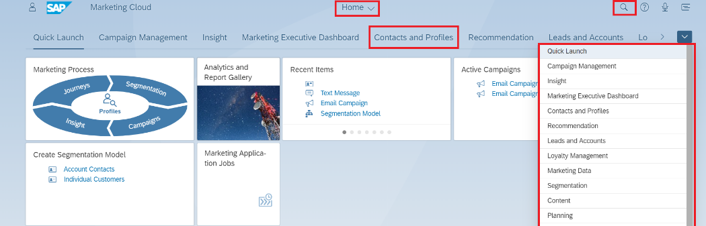
Figure 1: User Interface Navigation Component of SAP Marketing Cloud

No. | UI Navigation Component | Description
1 | Home | The home button provides SCE users the ability to return to the home page at any time.
2 | General Search | With this option, users can search for a required facet such as Contacts, Target Groups, Content templates, etc. When a user enters the text to be searched, the system will display a list that matches the text captured.
5 | Facets/Tiles | Applications or tiles will allow users to perform a specific task such as creating a campaign.

SAP Marketing Cloud functions are accessed via “tiles” contained on the home page as pictured in the following image:

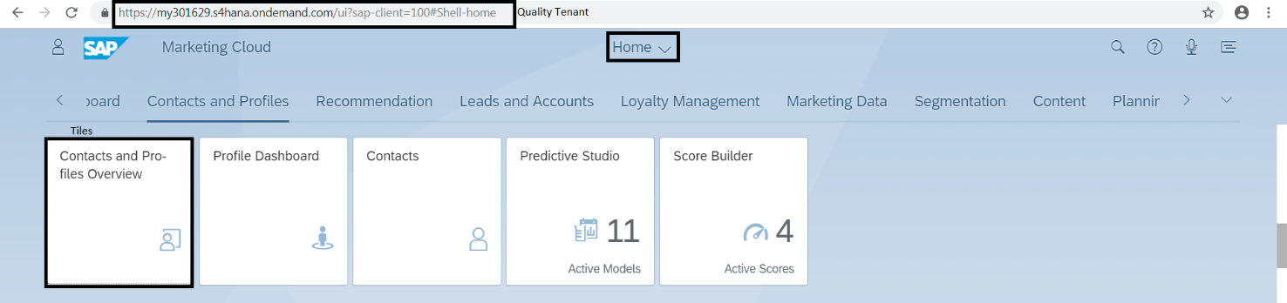
Figure 2: Home page of SAP Marketing Cloud

The tiles that the SCE end user will have available are the following (the functionality for these applications will be detailed in the sections throughout this BPD):

- Quick launch
It displays the most recent items created or accessed by the user.
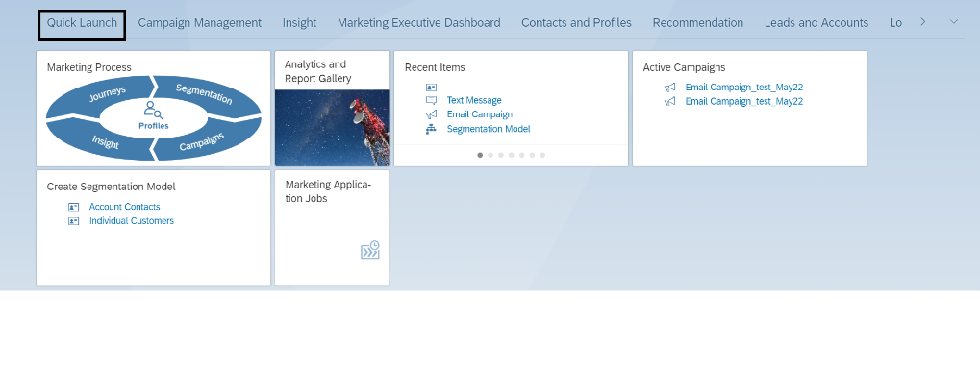
Figure 3: Quick launch Tiles

- Contacts and Profiles
The apps/tiles available for users are:
- Contacts and Profiles Overview
- Profile Dashboard
- Profiles
- Contacts
- Customer Journey Insight

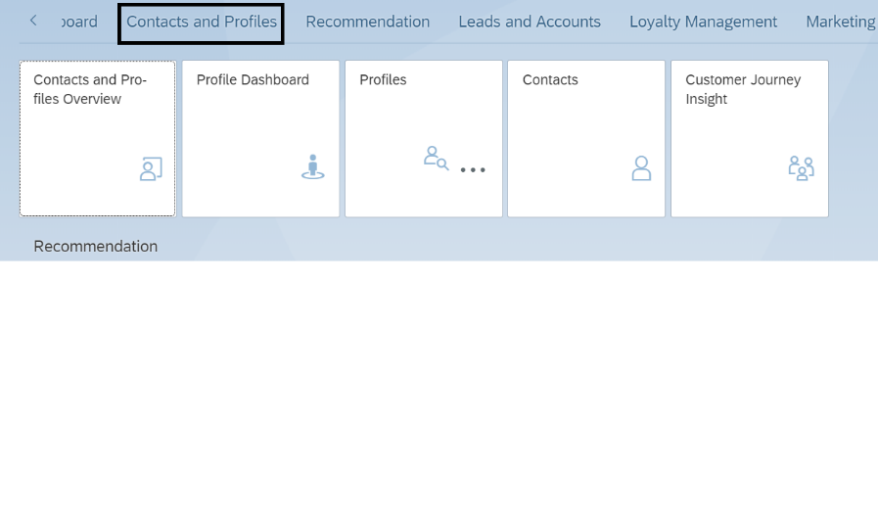
Figure 4: Contact and Profiles Tiles available for SCE

- Segmentation
The tiles available for users in this Business Group are:
- Segmentation Modeling
- Segmentation Models
- Segmentation Building Blocks
- Target Groups
- Template-Based Segmentation

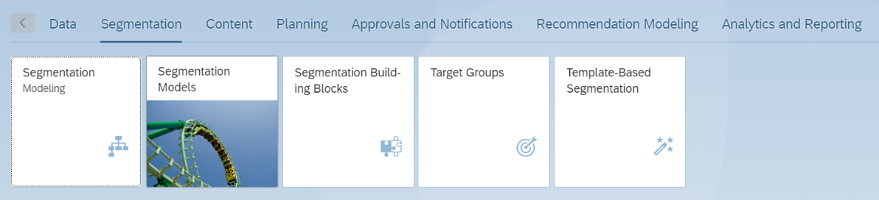
Figure 5: Segmentation Tiles for SCE

- Content
The app available for users in this Business Group is:
- Content Studio

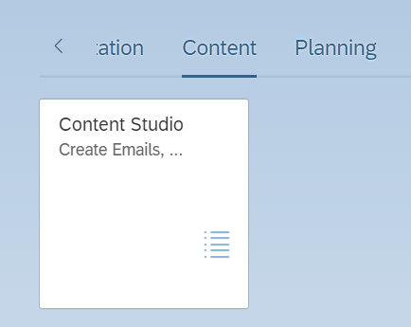
Figure 6: Content Studio Tile

- Campaign Management
The app available for users in this Business Group is:
- Campaigns
- Content Studio
- Target Groups
- Monitor Campaign Execution

- Leads and Accounts
- Transfer Leads
- Lead Dashboard
- Spotlighting Accounts

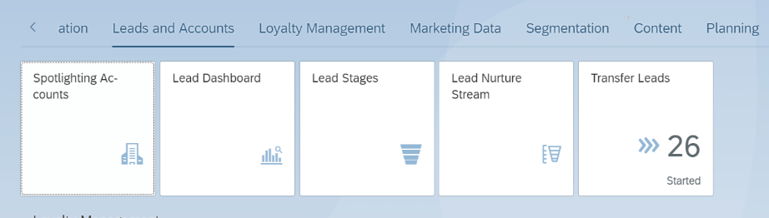
Figure 7: Tiles for Lead Management

- Import Data
- Import Data
- Data Load Monitor
- Import Data for Analytics

- Segmentation and Campaign Configuration
- Segmentation Configuration
- Suppression Rules
- Target Group Configuration
- Sender Profiles
- Provider Credentials (Admin ONLY)
- Communication Categories and Limits (Admin ONLY)

Contacts

Profile Dashboard
Existing Contacts in SAP Marketing Cloud will be viewed at a high-level through the Profile Dashboards application.

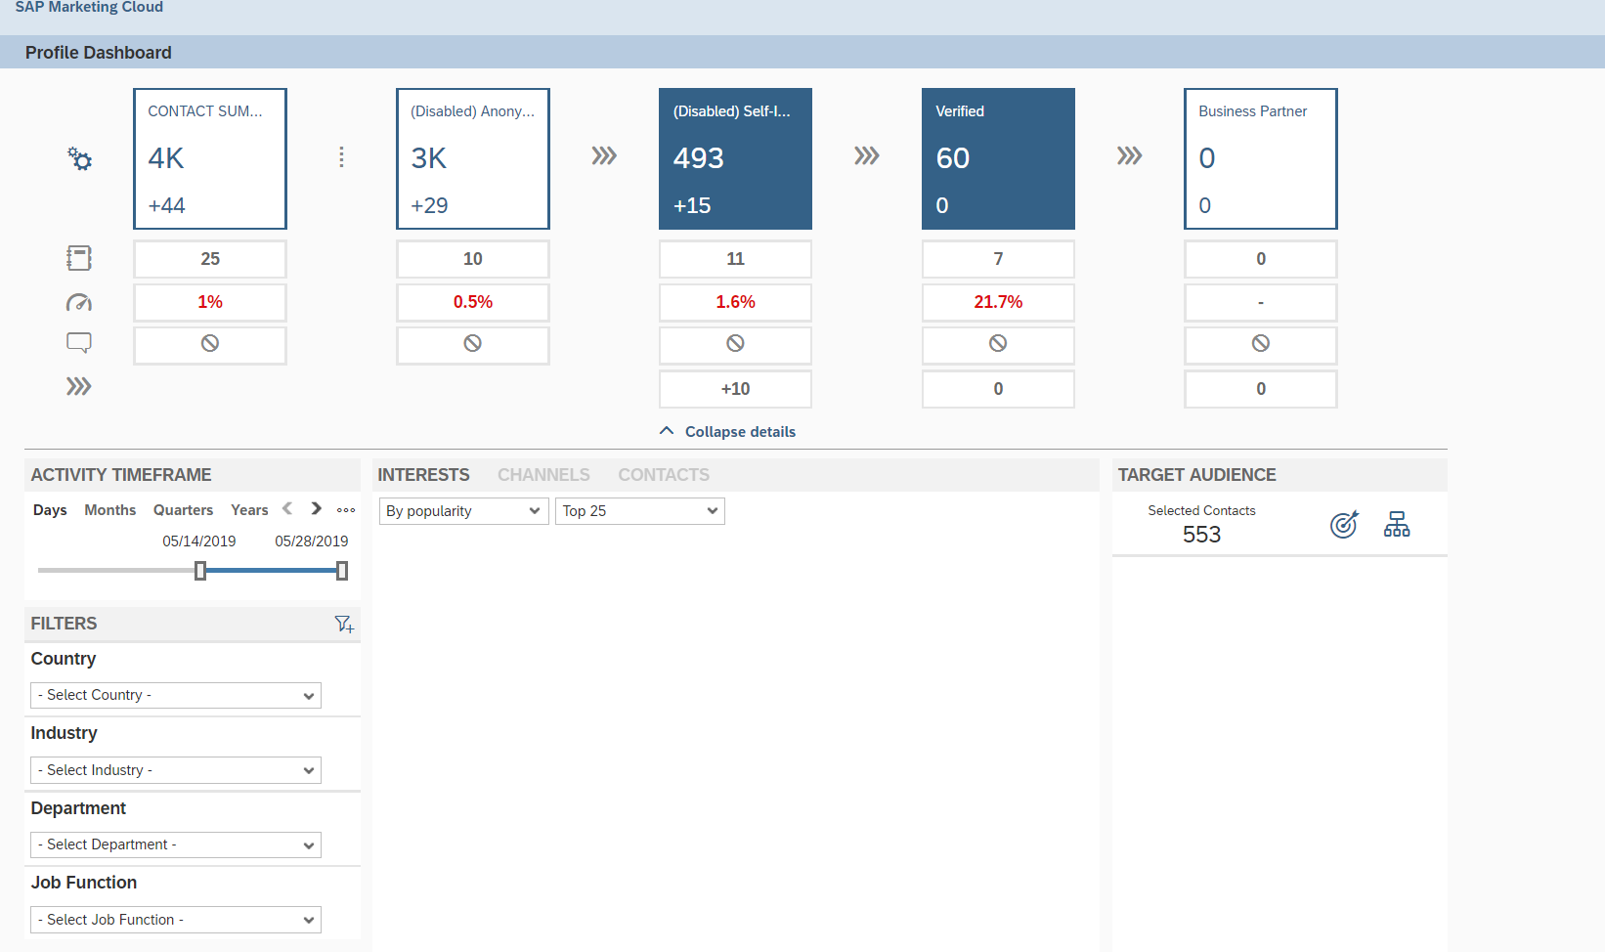
Figure 8: The Profile Dashboards app will provide users an overview of all the Contacts in SAP Marketing Cloud.

Each Contact will be classified based on the completeness of the data it has in SAP Marketing Cloud. The following table indicates the contact classification (known in SAP Marketing Cloud as Contact Level) that will be assigned automatically for each contact by the system according the description indicated below:

Classification of Contact | Description
Verified | The contact will be classified as verified if a link is clicked on in an email sent by SCE via an Email Campaign. This action indicates the email ID is verified.
Business Partner | This classification indicates that a “Contact” is an SCE customer. This means that the contact has an existing  SAP S4HANA ID and/or SAP C4C ID existing in SAP Marketing Cloud.

As ‘Contacts’ are the core master data of SAP Marketing Cloud, it’s important to understand how different sources contribute to their creation and enrichment. The sources that were identified based on the SCE requirements are displayed in the table below:

System Data Source | Priority level
SAP S4HANA | 1
SAP C4C | 2

Each source indicated in the table above will contribute to the building of a most valuable contact master data record in SAP Marketing Cloud. The priority level indicates the data source that has more value.

Contacts
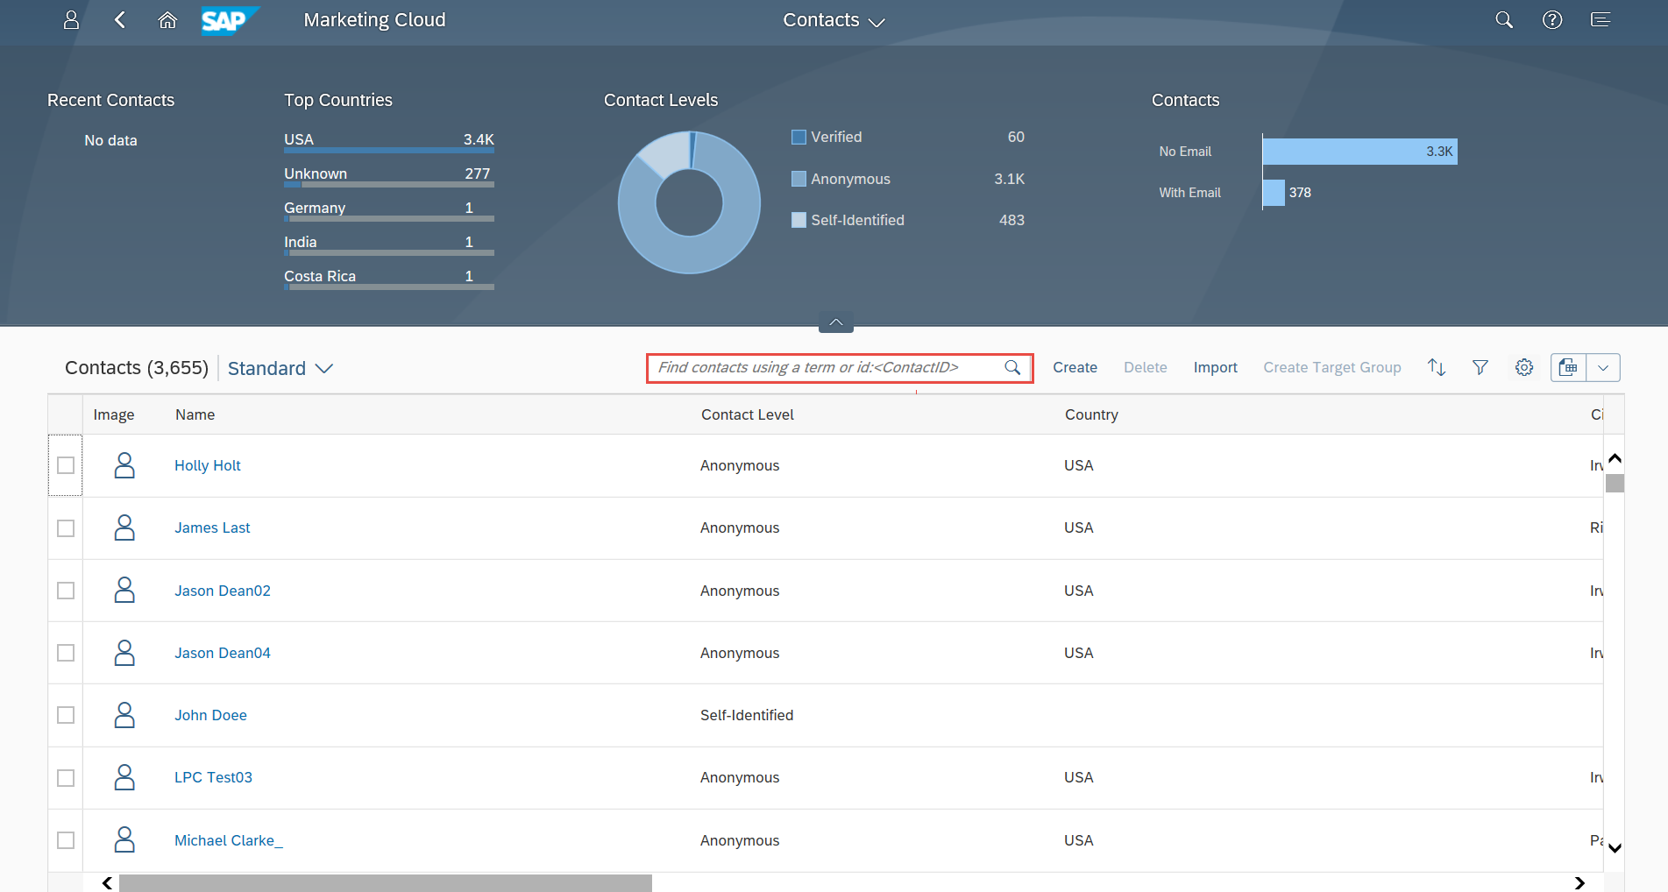
This application will be used by users to search and obtain information details about a specific Contact.
Figure 9: Contact App for search and visualize the detail data of a required Contact
Once a Contact is opened the Contact data will be displayed in the Facets depicted in the following image:
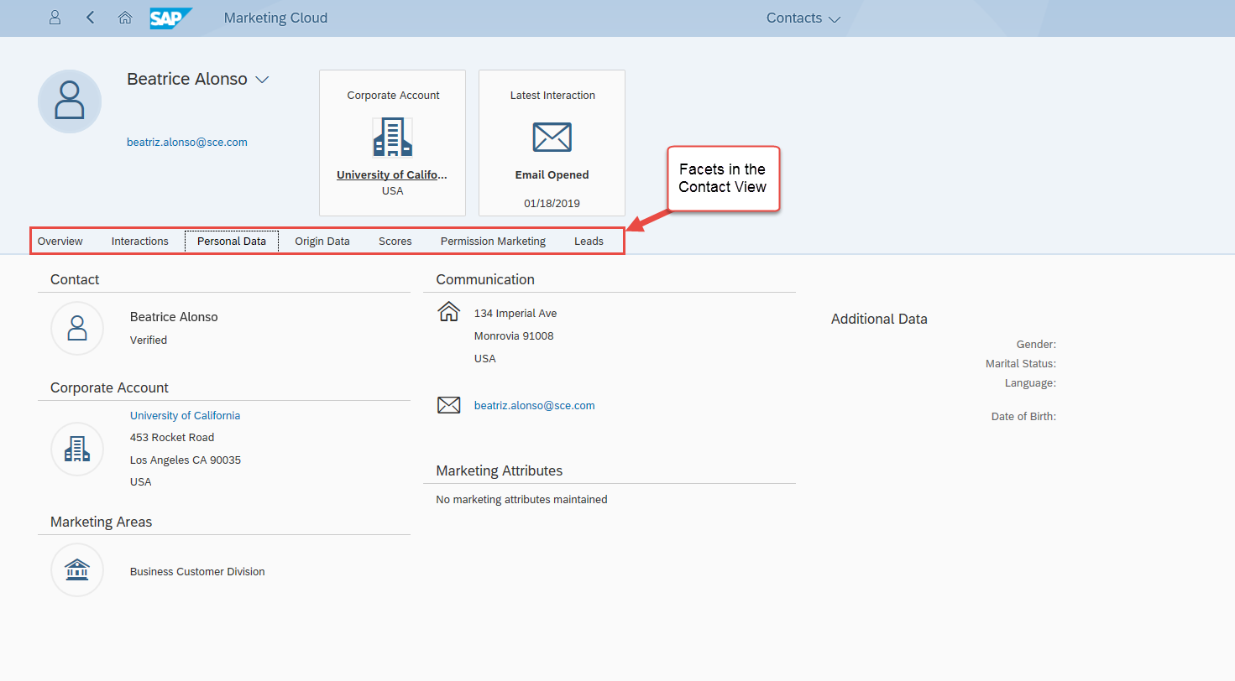
Figure 10: Example of a Contact View

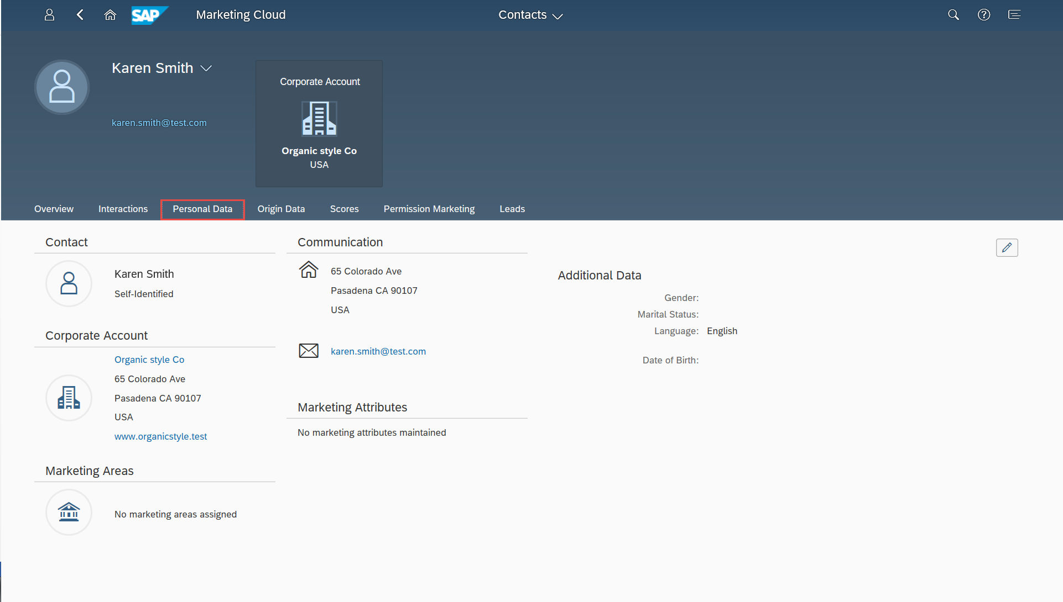

Personal Data Facet

In SAP Marketing Cloud the following fields will be displayed in the Personal Data Facet (the Customer Master Data is documented in BPD CIM-CS-01 - Business Master Data Manage Business Partner). The fields indicated in the following table will be replicated to SAP Marketing Cloud:

Information Type | Data | Data Source (Origin)
General Data | SAP S4HANA ID-Origin Data Facet | S4HANA
 | SAP C4C ID | SAP C4C
 | Title | S4HANA
 | Name | S4HANA
 | Full Name | SAP C4C
 | Last Name | S4HANA
 | House Number (e.g., 1234) | S4HANA (standard address)  (SAP Marketing Cloud will store only the main address)
 | Street Name (e.g., ½ South Main Street NW) | S4HANA (standard address)
 | City | S4HANA (standard address)
 | Region (State) | S4HANA (standard address)
 | Postal Code | S4HANA (standard address)
 | Country | S4HANA (standard address)
Communication Information | Telephone (Not used for Marketing Cloud) | S4HANA (based on Preference Center definition in S4HANA)
 | Mobile number | S4HANA (based on Preference Center definition in S4HANA)
 | Email | S4HANA (based on Preference Center definition in S4HANA)
Territory Management | Account Manager  Territory ID | SAP C4C
 | Segment ID.  This field can have one of the following values:  S1: Strategic Partner  S2: Optimized Service  S4: Self Service  HB: Home Builder  WG: Wholesale Generator  TP: Trade Professional  EC: ESP/CCA | SAP Marketing Cloud

Interactions Facet

This facet will contain all the Interactions created in the Data Sources listed above. An Interaction refers to the transactional data performed by the user or the Contact.
A standard Mash Up is required in C4C to allow the agent to visualize since the Contact Profile and specially the Campaigns of a specific commercial account in SAP Marketing Cloud, where Interaction History and Campaign Content can be viewed. .

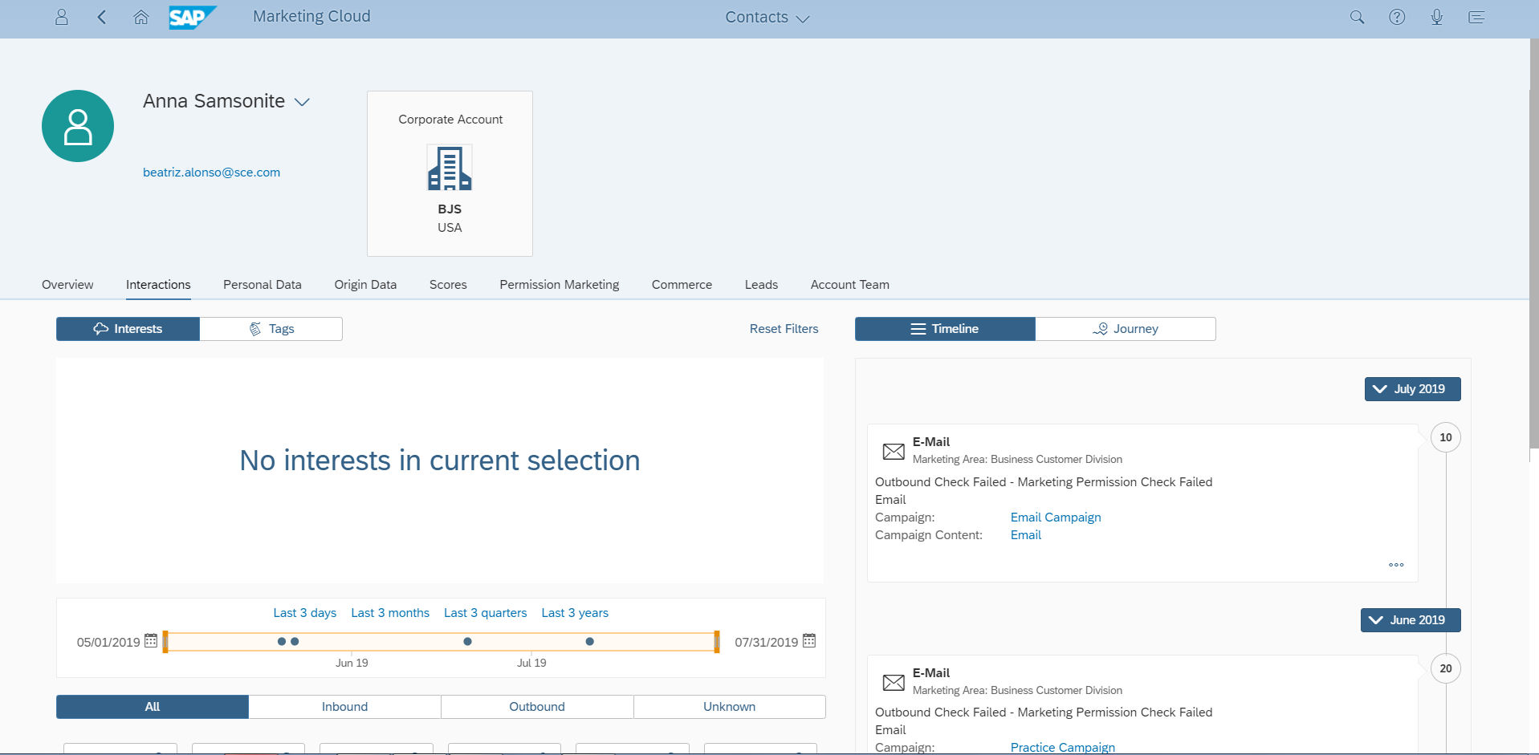
Figure 11: View of the existing Inbound/Outbound Interactions for the Contact selected

Figure 11 Shown above are the number of interactions with a specific contact (far right of screen) and the designated timeframe selected for the number of times communication takes place with the contact. This feature allows users to prohibit excessive contact to the customers.

Interactions identified for SCE are indicated in the table below:

Interaction Type | Interaction | Data Source
Email | Outbound email | SAP Marketing Cloud
 | Email opened | Nuance  (SCE will execute emails campaigns from SAP Marketing Cloud. Since Nuance will be the SMS and Email provider it will send the response back to SAP Marketing Cloud regards the email sent to the contact. This response will be recorder in SAP Marketing Cloud as an interaction)
 | Click through | Nuance
 | Email classified as CANSPAM compliant | Nuance
 | Hard email bounce back  (The recipient’s mail address is permanently rejected. It will happen if the email address is not valid or does not exist) | S/4 HANA
 | Soft email bounce back  (The recipient’s mail address is valid but the mail server bounced back if the recipient’s. It will happen if the mailbox is full or when the mail server is currently down). | Nuance
 | Outbound Check Failed  (The recipient’s email address is missing marketing permissions) | SAP Marketing Cloud
 | C4C Appointments | SAP C4C
Lead | Lead (documented in CIM-CS-16 - Manage Leads, Opportunities & Territory). If the customer has engagement activity within the campaign, the end user can transfer the lead into C4C to manage through the sales cycle. | SAP C4C
Opportunity | Opportunities (documented in CIM-CS-16 - Manage Leads, Opportunities & Territory) | SAP C4C
Campaigns | SCE Campaign | SAP Marketing Cloud

Account Manager Segmentation
Account managers and their customer list can be queried using the Segmentation tile by choosing to segment via account manager or territory ID.
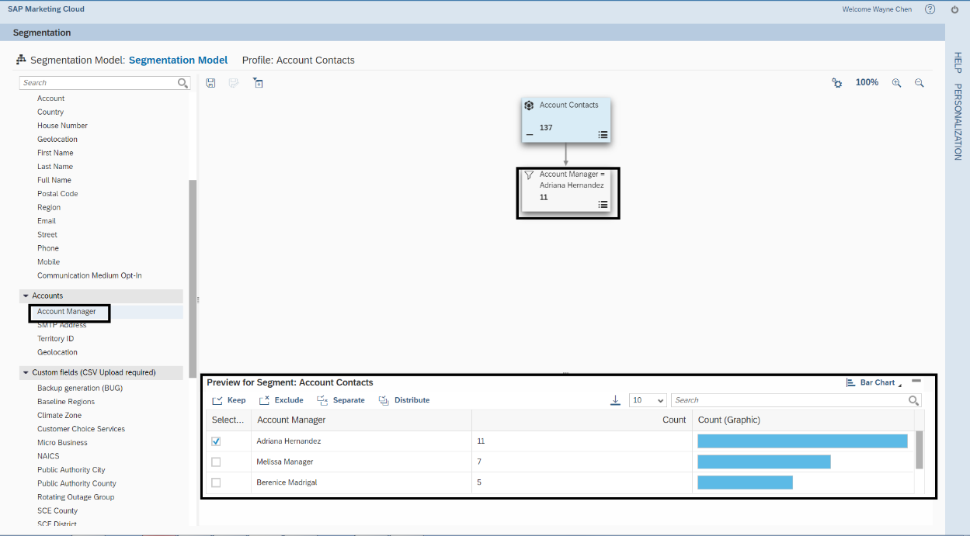
Figure 12: View of the Account Manager View in Segmentation

Scores Facet
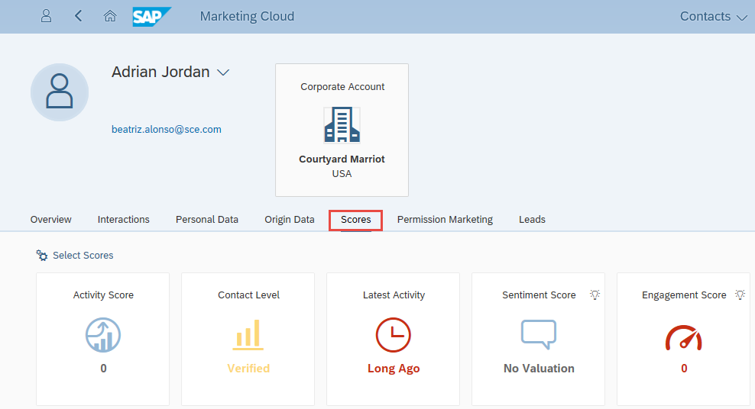
Figure 13: Scores that will be used for SCE

A score provides a calculation to understand the behavior of Contacts. The following scores pre delivered by SAP Marketing Cloud will be used for users to track the engagement activity of the contacts. (Example - not opening an email or clicking of a text 5 times or more).

Score Name | Description
Activity Score | Indicates the activity of a contact based on the inbound interactions in percentage.
Engagement Score | Indicates how engaged a particular contact is.  Based on all the existing contacts in the system, this score considers the contact who receives the higher number of interactions in a period of 90 days as a reference and compares with the number of interaction received for the particular contact.  The higher the score, the more engaged the contact is.

The Scores shown in the table above will be available in the Contact Profile and in the Segmentation that will be used as a Filter/attribute to create Target Groups desired by users.

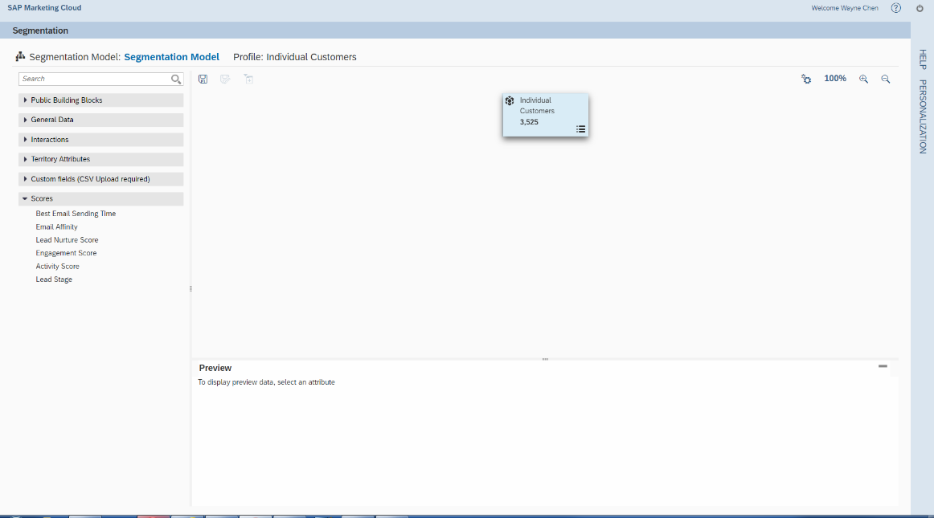
Figure 14: The scores will be available for the Segmentation tool.

Permission Marketing Facet

Permissions in SAP Marketing Cloud indicates that a contact accepts to be contacted via a certain communication mediums using a specific ID such as Email or text messages (SMS).

A contact may have multiple active emails, mobile numbers (SMS enabled), and will be able to select multiple channels for delivery as well as their default preferences for each type of communication.

The contact may opt out (un-enroll) for outbound communication of campaigns by replying with STOP/STOP ALL when receiving a SMS text message or Unsubscribe in email communications. If the customer request “Unsubscribe” or “Stop/Stop All”, Nuance will send their request back to UPrefer, end date the customer preference and create a BP Contact under Marketing Permissions.

If a user enters an updated email address, mobile number, or landline number into S4HANA replacing an existing phone or email address, SAP Marketing Cloud will automatically update any communication preferences that were previously created for contact. The user preference for Email, and mobile will be managed in S4 HANA.

Opt-outs are captured in uPrefer in S4HANA as contacts are automatically assumed to be opt-in. Preferences will be replicated to SAP Marketing Cloud and will be displayed in the Permission Marketing facet (as shown in the Figure 15 below). The data replication between S4HANA and SAP Marketing Cloud will be unidirectional (from S4HANA to C4C, and then to SAP Marketing Cloud) however, in order to preserve data consistency the updates/changes of the user preference must be done in S4HANA.

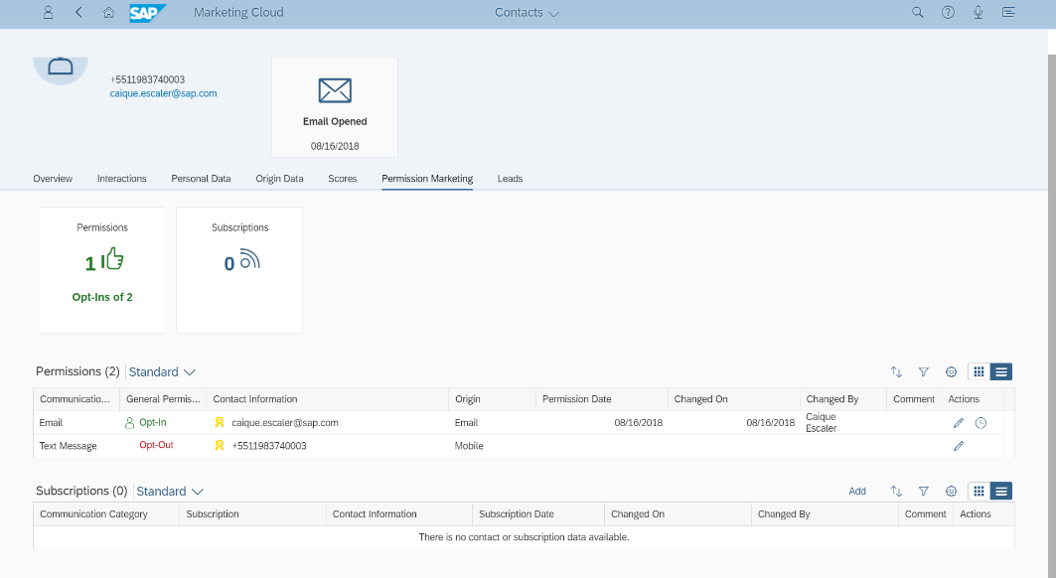
Figure 15: User Preference stored in S4HANA will be displayed in the Permission Marketing Facet

The user preference data that will be displayed will be:
- Communication medium: Text message (SMS), Email.
- Contact information: corresponding value for the communication medium.
The preference center will be updated in S4HANA and then this information will reflect in SAP Marketing Cloud. There is just one way communication (unidirectional data transfer) from S4HANA to SAP Marketing Cloud.

The details of the Communication Information and Preference Center to be stored in S4HANA can be found in BPD CIM-CS-01 - Business Master Data Manage Business Partner.

Segmentation
The Segmentation application (also known as the Segmentation Builder) is a standard tool that allows users to use filter attributes and filter operations for the segmentation of the existing Contacts.
The attribute group will contain all the filter attributes defined in the following table to be used in order to create Target Groups, which will provide users the ability to create target groups by previous campaigns and response history.

Attribute Group | Filter attribute for Segmentation
General Data | Title
 | First Name
 | Full Name
 | Last Name
 | Street
 | House Number
 | City
 | Region (State)
 | Postal Code
 | Country
 | Industry
 | Geolocation
 | Mobile
 | Communication Medium Opt-In
 | Date of Latest Change
Interactions | Interaction Status
 | Channel
 | Interaction Type
 | Interaction Date
 | Interaction Reason
 | Content Title
 | Campaign Content
 | Text of Launch URL
 | Interaction Date
 | Communication Medium
 | CRM Campaign
 | Campaign
 | Interest
Accounts | Account Manager
 | SMTP Address
 | Territory ID
 | Geolocation
Territory attributes | Account Manager’s Email Address
 | Lead Stage
 | Territory ID
 | Geolocation
Custom Fields | Backup Generation (BUG)
 | Baseline Regions
 | Climate Zone
 | Customer Choice Services
 | Micro Business
 | NAICS
 | Public Authority City
 | Public Authority County
 | Rotating Outage Group
 | SCE County
 | SCE District
 | Small Business

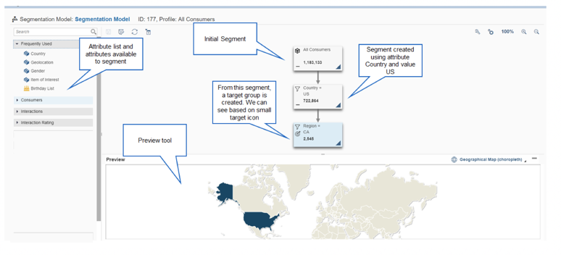
Figure 17: Segmentation Builder View

Segmentation Builder Component | Description
Attribute Search | Used to find characteristics or key fields by name. Only alpha characters are allowed for the search.
Attribute | Will be used to filter the universe of Contacts that exist in SAP Marketing Cloud in order to create a Target Group.
Initial Segment | Represents the universe or total of Contacts existing in SAP Marketing Cloud.
Preview Tool | An interactive visualization of the data regarding the segment and attribute selected.  Starting with the initial segment, filter attributes can be applied to build up a segmentation structure.

After selecting the attribute and choosing the value in the preview tool, there will be an option to create the segment which can be selected by the user, as shown in the image below:

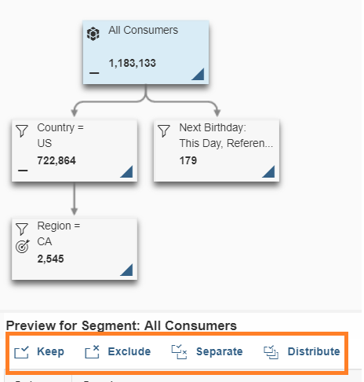
Figure 18: Actions available for Segmentation Builder

Below you will find the options for Preview Segment below:
Actions | Description
Keep | Use this action to generate a segment that contains the contacts that have the selected matching attribute value is matching.
Exclude | This action does the opposite of ‘Keep’. It excludes the contacts where the selected attribute value is matching.
Separate | This action combines the two previous modes. It is composed of two segments; one containing the contacts for whom the selected attribute value is true, and one for the contacts excluded by the selected value.  Note: Applying the segmentation filter Separate does not split a segment.
Distribute | Use this action to generate a defined number of segments for single attribute values or for a range of attribute values. For ranges, a segment is created for each range value. For example; if the Zip Code key is selected for Monrovia and Irwindale, two different segments will be created after user clicks distribute.

Building Blocks
A Building block is a segmentation structure including a set of often used segmentation filters.

Users can use the building blocks in segmentation models in order to create recurring/reusable Target Groups.
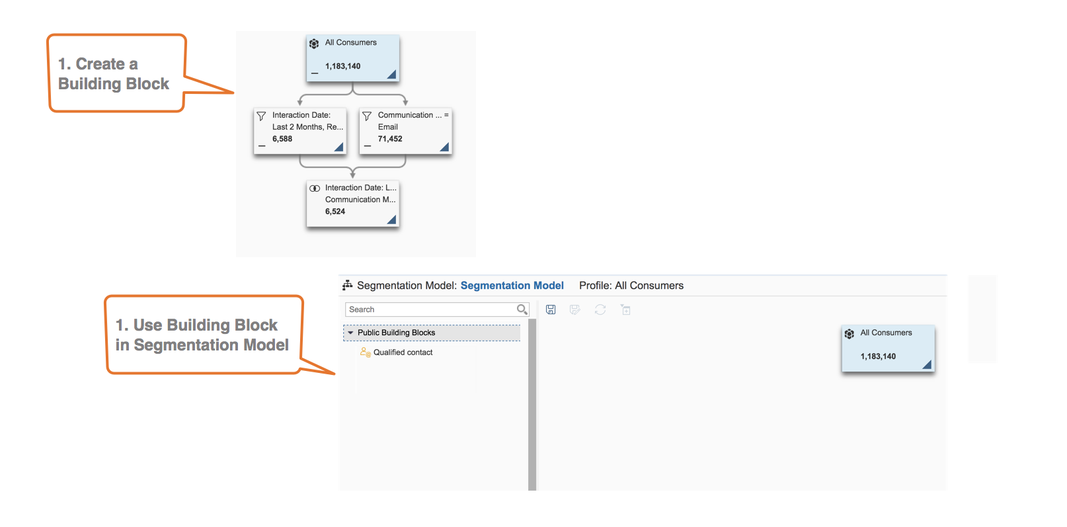
Figure 19: Building Block (creating recurring Target Groups)

Import Data Elements

A CSV file will be used to store the required SCE data elements (i.e. data for Custom Fields, Contacts, Interactions) to be uploaded into SAP Marketing Cloud.
Once the template is populated with the desired contacts, the user can upload the template by selecting the Import option as shown in Figure 20 below.

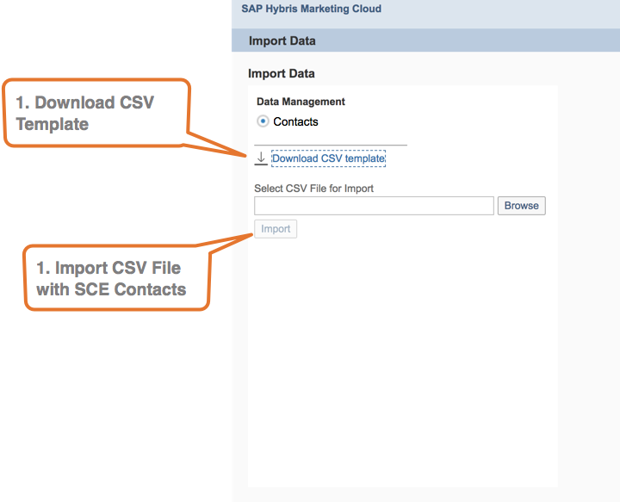
Figure 20: Import Data Application to upload Contacts.

Target Groups
A target group is an audience that will receive marketing related communication. This audience is defined according to criteria, such as geographical location or common interest.

To create a Target Group, the user will have to select the option Create a Target Group from the segment builder.
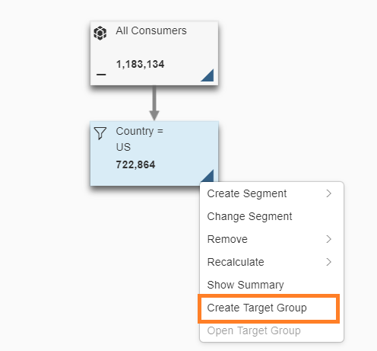
Figure 21: Example of Target Group Creation from the Segment builder.

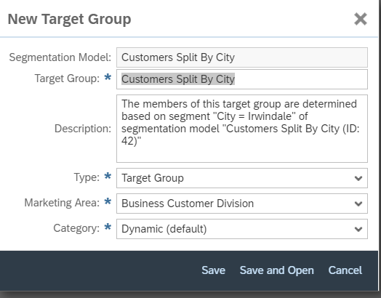
Figure 22: Required fields to create of a Target Group

After selecting the option, a popup will appear with additional information required to complete the action:

- Segmentation model: a required field, stores all the segments previously created by users.
- Description: not a mandatory field but contains a specific description about the target group. By default, the system gives a short description about the filter applied to the segment, which can be changed by the user.
- Type: contains the value “Target Group”.
- Marketing Area: a mandatory field, which designates the organization/business unit that creates the target group. For SCE the values will be BCD, CSOD and CP & S.
- Target Group Category
- Dynamic (Default option)
Dynamic target groups are updated according to the filter defined in the segmentation model. The dynamic target groups will be used for campaigns that are carried out regularly. Before the campaign is executed, the members in the target group are updated depending on whether they meet the filter criteria for the campaign.
- Static
Static target groups do not update their members automatically but keep their members and require users to update them manually.
- Live
Live target groups do not maintain their members permanently. They are derived on an adhoc basis when requested by the user or the system. With each request, a check is carried out to see which members of the segmentation profile meet the filter criteria for the target group.
After selecting and generating the selected options, the user can select the following options: Save, Save and Open or Cancel. If the user selects Save, the Target group will be created, and the popup will be closed. User will be able to see that the Target Group was created by checking the small highlighted item below:

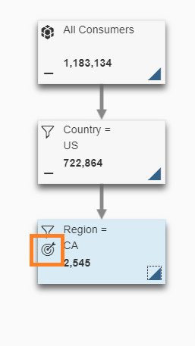
Figure 23: Icon that indicates the Target Group creation

To view the target group, the user must open the options by clicking the triangle and by selecting the Open Target Group.
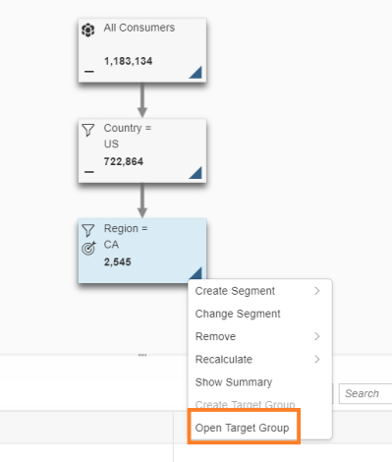
Figure 24: Direct access from the Segmentation tool to the Target Group

If the user clicks save and open, a new web browser window will be created to display the target group.
Once the target group is opened, the following information will be displayed.

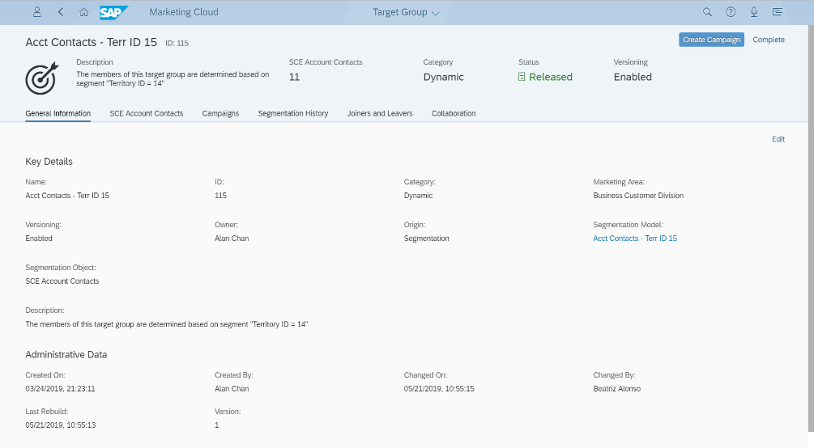
Figure 25: Target Group application view

The following information will be displayed:
- Category
- Status
- Snapshot
- A Snapshot is an update to the member list that users can trigger to visualize which Contacts join and/or leave the Target Group.
- The last Snapshot is displayed. If the icon is selected, the snapshot tracking is disabled.
A target group can have one of the following statuses:

- In Preparation: This is the initial status of a target group.
- Released
- After preparing the complete target group, the user can select Release to activate the target group and make it visible to everyone within SAP Marketing Cloud. Once a target group has been released, it can no longer be edited.
- Sending a campaign for a target group that is not yet released, will automatically release the target group.
- Completed
- The user can select Complete to complete a released target group when it will no longer be used in a campaign. Once a target group has been completed, it can no longer be edited.
- Discarded
- The user can select Discard to indicate that the target group is not to be used. Once a target group has been discarded, it can no longer be edited. Additionally, a user will not have the ability to discard a released target group.

Figure 25 will display the members. On the top of the image, there will be different tabs to display information related to the target group.

Campaigns Facet

The Campaign Facet allows the users to see all the campaigns created to target group being displayed (See Figure 26 for reference).

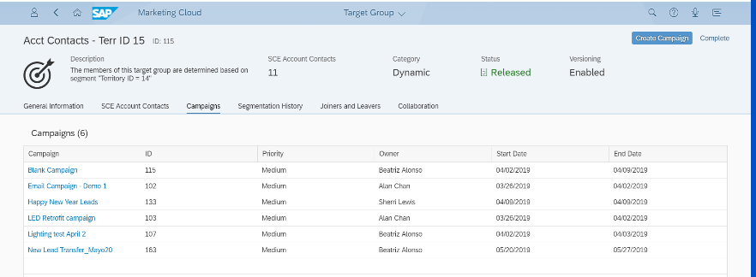
Figure 26: Campaign associated to the Target Group

Segmentation History Facet

This area will display the segmentation model as shown in Figure 27.
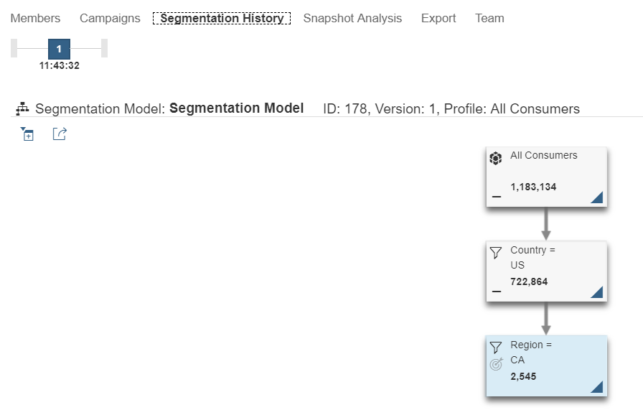
Figure 27: Segmentation Model

The dynamic target groups will give users a view of the updates of the list of Contacts contained in the Target group. This only works for the target groups with snapshot enabled. Figure 29 displays a table view.

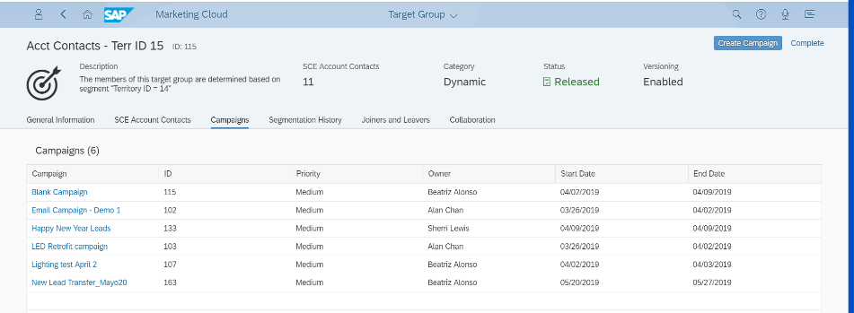
Figure 29: Graphic view of the history of Joiner and leavers from the Target Group

Export Facet

This area will display the templates available to download the information from the contacts in the target group. The file downloaded will be in.CSV format and can be used by users from an external system.
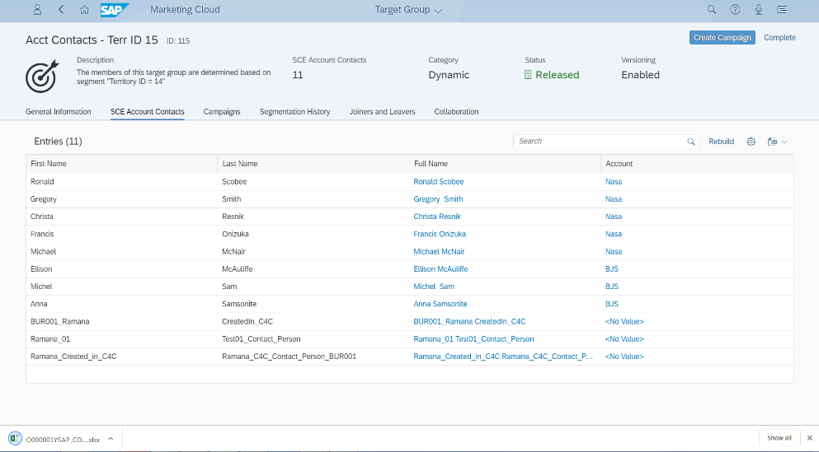

Figure 30: View of Target Group export functions that will be available for SCE.

Content Studio
The Content Studio is a standard tool that will allow SCE graphic designers to create the layouts used for the Campaigns. Figure 31 displays the types of campaign options and templates that will be available for users in the Content Studio Application:

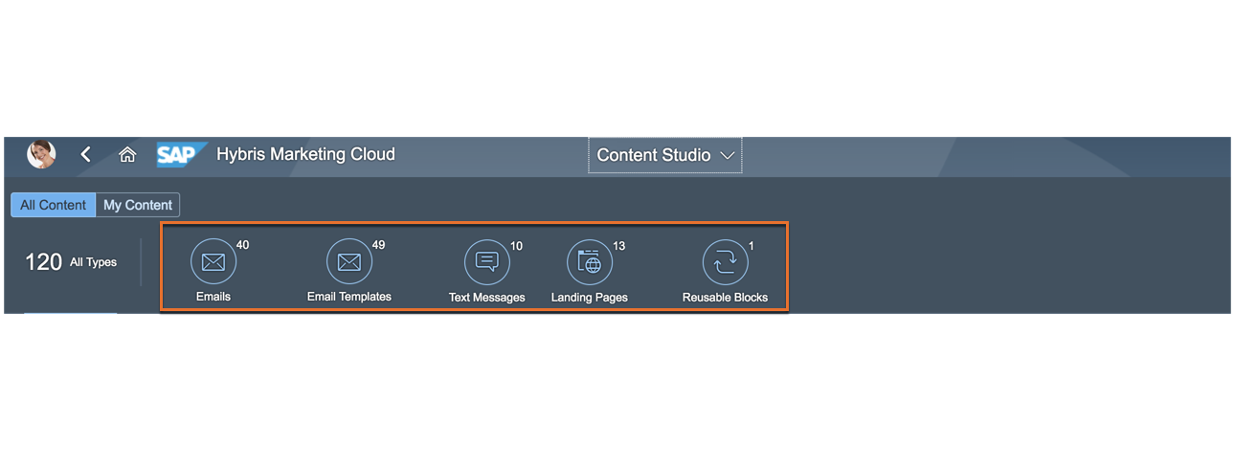
Figure 31. - Content types that will be available to SCE in the Content Studio

- Emails: This content type will be used for the email campaigns.
- Email Template: This is a reusable layout that can be adapted to SCE’ specific requirements in order to reduce the content creation effort and ensure a standard layout.
- Text Messages: This content type will be used for the SMS campaigns.
- Landing Pages: Users can use this content type to create a stand-alone web page.
- Reusable Blocks: Every block in an existing layout can be defined as a reusable block and can be used in other layouts/templates. For instance, a user can create a reusable block that filters via zip code, then NAICS code.

The Content Studio Application is displayed in Figure 32:

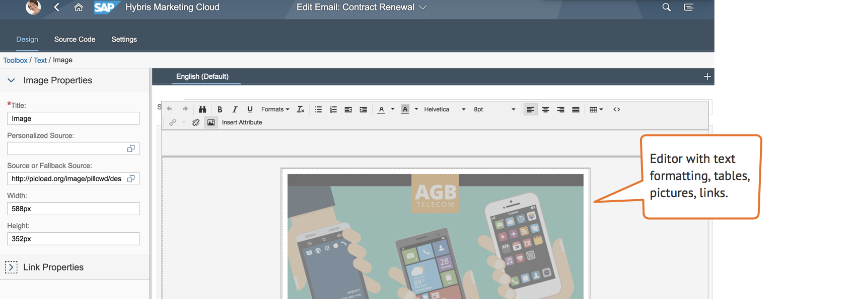
Figure 32: Content Studio application view

Users will perform the tasks related to the edition of the Campaign Layout:
- Ability to insert graphics and logos to be added to layout being created.
- The Content Studio has the standard editor with text formatting of the font and layout, tables and the capability to insert pictures and links.
- Spell check. SAP Marketing Cloud leverage the spell check of the web browser where the user is logged in.
- Ability to insert dynamic attributes in the header and body template.

Uploading attachments into the layouts is not possible in SAP Marketing Cloud. However, the attachments can be managed in a Digital Asset Management System (for example Open Text). A link to the attachment can be inserted into the layout created in the Content Studio application.

Sender Profile Settings
The Sender Profile defined in the Setting Template will appear in the email that is sent to the contact. The business user has to leverage the “Send on Behalf Personalization” if they are required to create and release a campaign on behalf of the Account Manager. A Sender Profile will be created by users for each specific name and email address required (for example, Account Manager)

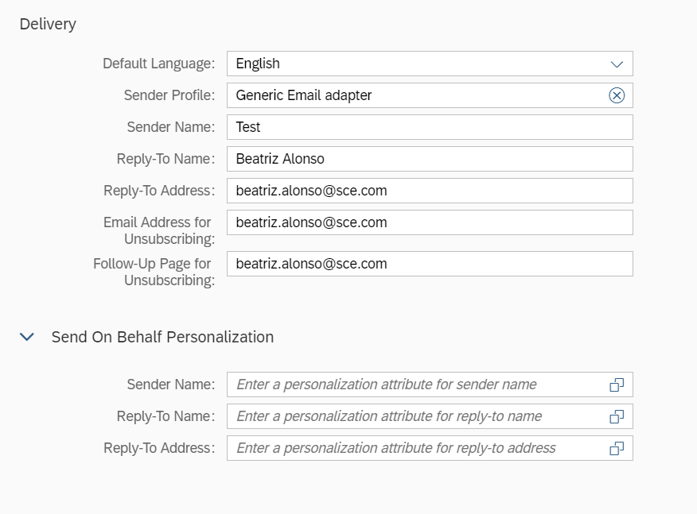
Figure 33: The Sender Profile Settings will be defined for each template created.

    - Insert links

Users will use links in the layouts for the following mandates:
- A link to the privacy notice for emails sent
- A link related to terms and conditions for emails sent.
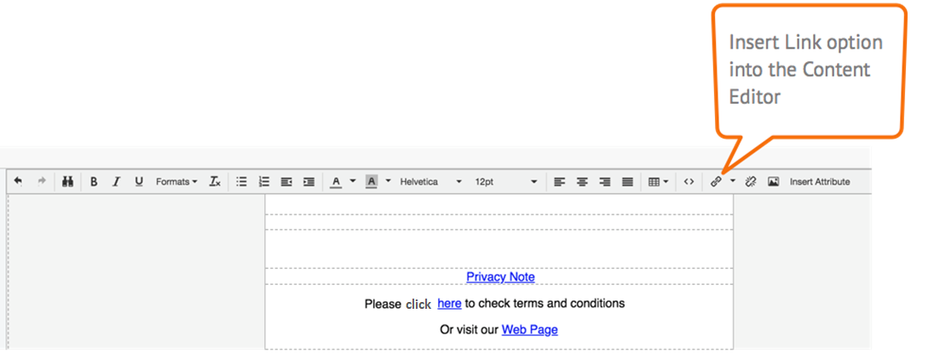
Figure 34: Content Editor with links inserted displayed in blue.

Links can be inserted in the email templates. SCE will be able to track open and click through rate. To enable this, the user will provide for each link within a campaign a so-called sap-outbound-ID which can be automatically appended as a parameter to the link URL. Each link can only have one sap-outbound-id, but the layout can have several links.

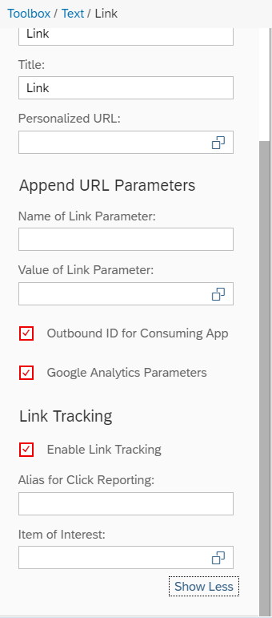
Figure 35: A link can be trackable if the check box Enable Link Tracking is enabled

When the email is sent the Outbound-ID will be displayed as is depicted in the following image:
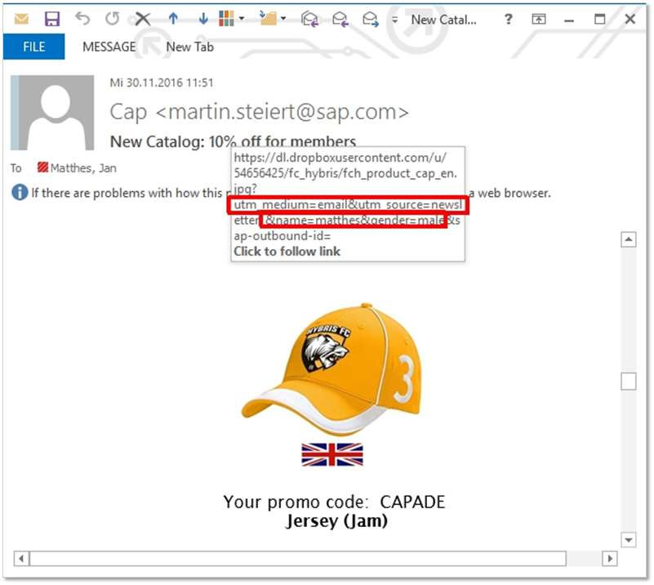
Figure 35: View of the Outbound ID into the email sent.

Dynamic Attributes For Header And Body Template

A dynamic attribute is defined as a field that changes according the value of the Contact; for example, the last name, mobile number, etc.

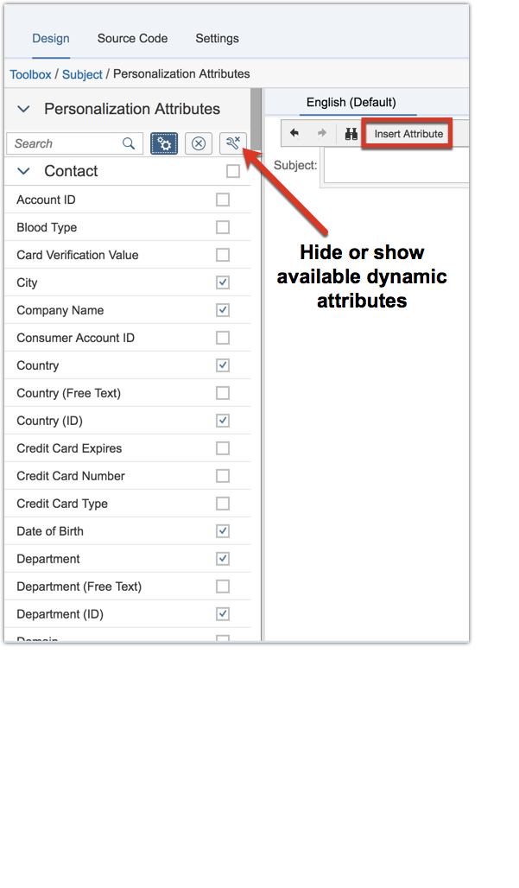
Figure 36 – Dynamic attributes are located in the left side of the Design Tab

Users will have the following dynamic attributes for the header layout:
Attribute Group | Dynamic Attribute (Header layout)
General Data | Title
 | Last Name
 | Email

The Body Layout and the dynamic attributes in the Content Studio are displayed in the table below:
Attribute Group | Dynamic Attribute (Body layout)
General Data | Title
 | Title (ID)
 | First Name
 | Last Name
 | City
 | Company Name
 | Date of Birth
 | Department
 | Department (ID)
 | Function
 | Function (ID)
 | House Number
 | Region (State)
 | Postal Code
 | Country
 | Industry
 | Industry (ID)
 | Cell Phone number
 | Email
 | Language
 | Language (ID)
 | Marital Status
 | Marital Status (ID)
 | Postal Code
 | Region
 | Region (ID)
 | Street
 | Web Site
Current Campaign | Campaign
 | End Date
 | Name
 | Short Descript.
 | Start Date
Account Manager | Email Address
 | First Name
 | Full Name
 | Last Name

Upload External Templates

A template can be created directly using the Content Studio or be created in an external tool and uploaded to the email editor as a template. The user can modify these uploaded templates as desired.
The formats permitted in order to execute this upload must be HTML and XML formats. An SCE HTML/Graphic Designer will be required to create these external templates.

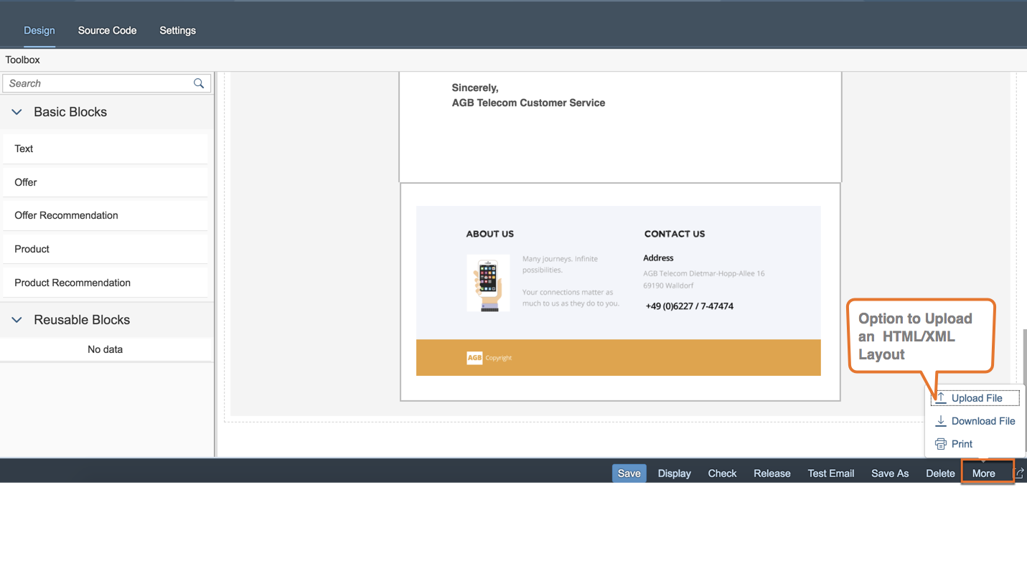
Figure 37 – Upload File option will be used by SCE to use layouts created in an external tool.

Test Layout

The Test Email button will be used by users in order to Test the layout created. It can be executed by the following options available in the Content studio:
- To send using Attribute Values: the values for the dynamic attributes contained into the layout can be inserted manually.
- To send using a Target Group: the layout test is sent to the Contact contained into the Target Group selected for this option.
- To send using a Contact: SCE can select a specific Contact to perform the Test.

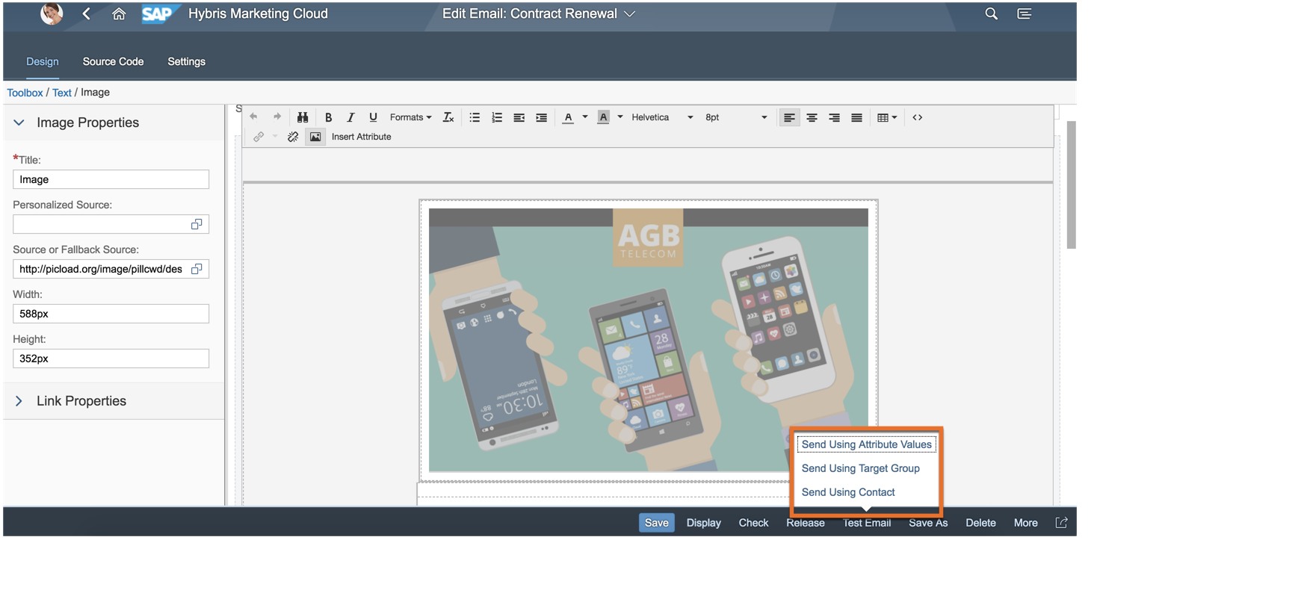
Figure 38: Test option displayed into the Content Studio

All the layouts created into the Content Studio are a responsive design, the layout adapts depending on the screen size of the device being used.

Campaign Management
A campaign is an action that will be used for various activities of the Contacts that have been categorized into a target group.
Users will create campaigns by using the Campaign application. Once the user selects the create button a popup will appear to populate the campaign’s information
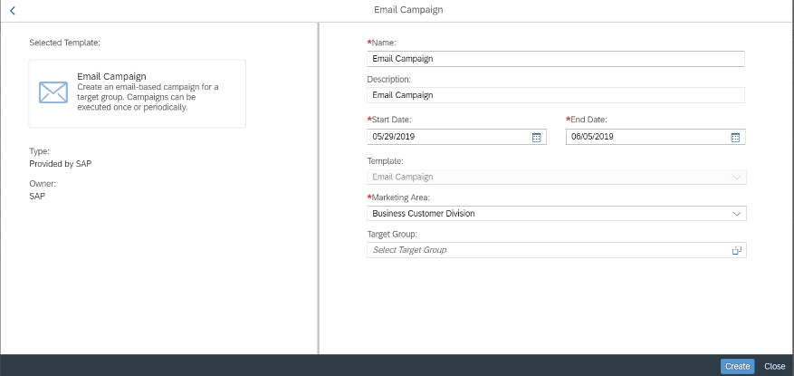
Figure 39: Screenshot of Creation of a Campaign

User will have to populate the required information identified by the red asterisks in Figure 39. The Campaign will contain the following information:
- Name: a special Nomenclature for the Campaigns created in the system will be defined by SCE.
- Description: brief text of the purpose of the campaign.
- Start Date/End Date: period of time for the Campaign is planned.
- Template: field to select the Content type for the Campaign.
- Marketing Area: the values that will be available for this field are BCD, CP&S, and CSOD.
- Target Group: this field will display the Target Groups created in the system in order to assign the required one to the campaign.
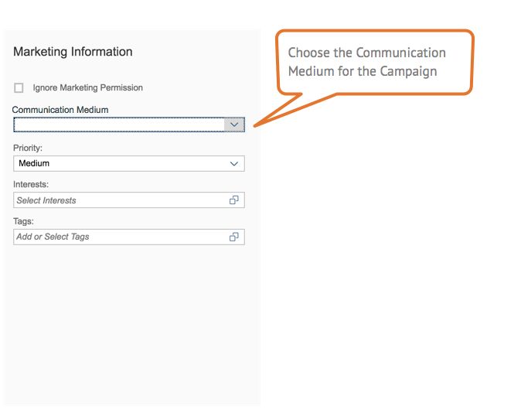
Figure 40: Communication Medium field view

The Communication Medium field will permit users to choose the Communication for a Campaign, the following values will be displayed:
- Email
- Text Message (SMS)

Once the Campaign is saved a unique campaign ID is created and is viewable in the Campaign designer (see Figure 41).
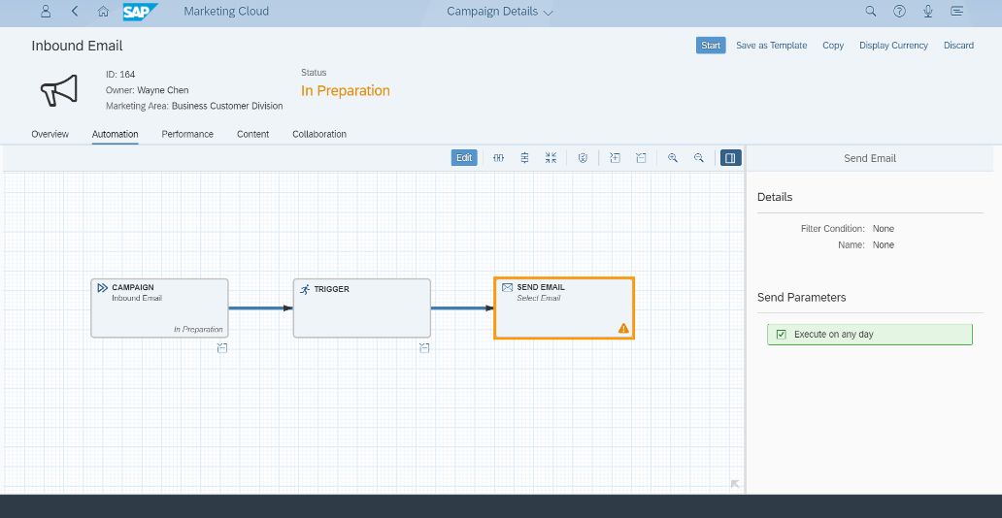
Figure 41: Campaign Designer view

The ‘Interactions’ capabilities that users will have available through the Campaign creation are:
- Create C4C Lead
- Send Email
- Send Text Message

In the campaign designer, the system can define the execution schedule see Figure 41.
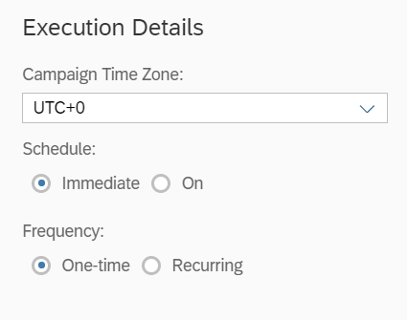
Figure 42: Execution schedule can be one time or recurring

As the campaign is being created, users can add an event to trigger an action displayed in the following image:

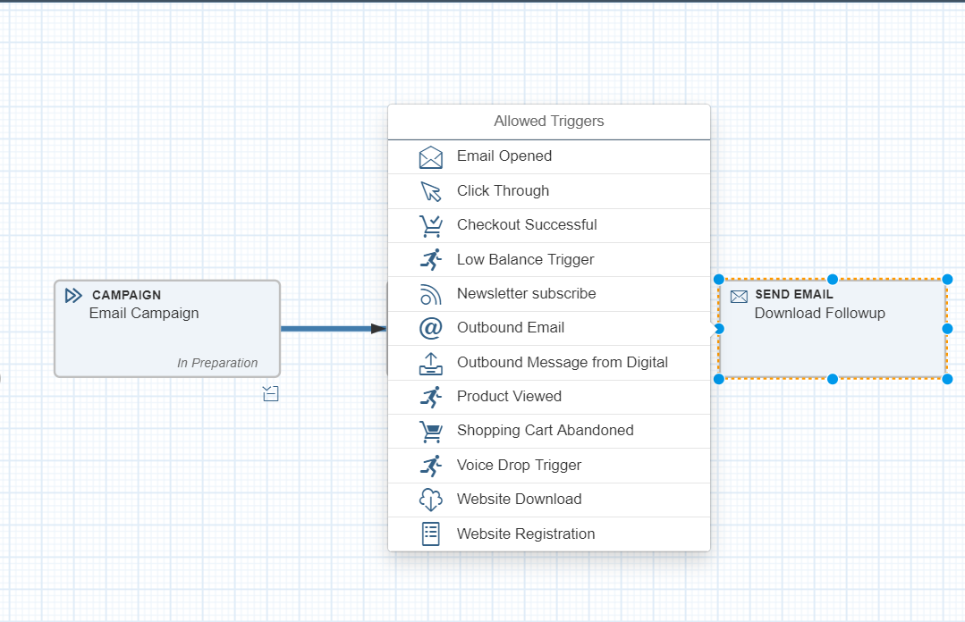
Figure 43 – Events that will be available for SCE to trigger an Action

This will allow user to set further actions. This allows users to selectively resend email campaign to those BPs who have not opened the email depicted in Figure 44.

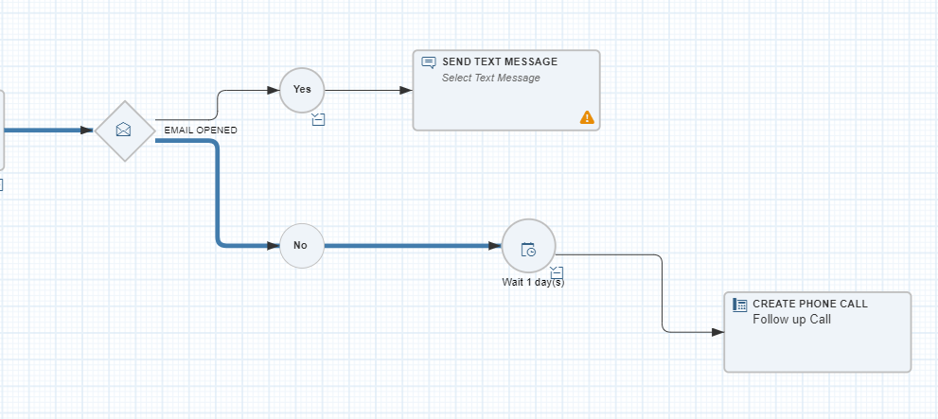
Figure 44: Example of Action Triggered based on an Event.

A campaign can have various statuses that depict the lifecycle of a campaign. The lifecycle of a campaign is denoted by the following fields Status and Execution as can be seen in the following figure 45:
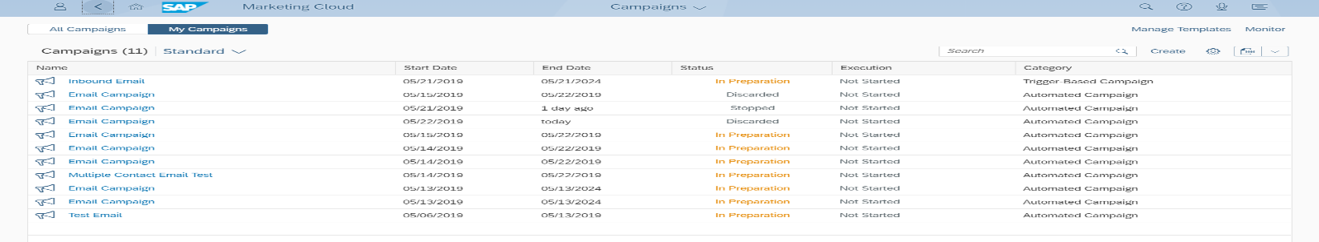
Figure 45: Status and Execution fields represent the lifecycle of a campaign.

Status | Description
In preparation | When the campaign is being created, the initial status of the campaign is Preparation.  In this status the owner of the campaign must notify manually to the following distribution list EmailComplianceReview@sce.com to request review the campaign prior release the campaign.  In this status the Execution field value will be:  - Not started: This is the initial value of the execution status. The campaign is not started.
Released | After preparing the campaign the user will select the Start button to start campaign execution. The status changes from In Preparation to Released.  When a campaign is released the attributes of the campaign header can be changed, but changing the automation is not possible.  In this status the Execution field value will be one of the following:  - Running: this execution status is set immediately after the campaign has been started and it indicates the actions defined in the campaign are running.  If the execution of all actions has ended the execution status is changed to Finished or Error Occurred.  - Finished: this value is set when the execution of all actions of the campaign have ended successfully.  - Error Occurred: this value is set when the execution of all actions of the campaign have ended with error.  - Paused: If the user selects the Pause button then, the Execution field will have this value.  A manually paused campaign, all follow-up triggers, such as reacting on Click Through of links in emails sent before the campaign is paused, are still processed.  The user can starts the campaign again and the execution status is set again to Running.
Stopped | This status can be assigned to a campaign manually or automatically.  a) Manually  If the user selects the Stop button then none of the actions assigned to the campaign are executed.  Also stops the execution of follow-up actions. Aggregated success is frozen and no longer receives updates. You cannot edit or restart campaigns that are stopped.  b) Automatically  When the campaign reaches the End Date the campaign is updated to the status Stopped automatically (due to it means the execution stops automatically) although all reporting is still available related to the campaign.
Discarded | SCE can discard a campaign while the status is In Preparation. The user will select the Discard option to indicate that the campaign is not to be used. The status changes from In Preparation to Discarded. However, it is not possible to discard Released campaigns.

Marketing agencies can be assigned by SCE in the Facet Collaboration into the Campaign to track, store and modify which agency will be used for each campaign as is displayed in the following image:

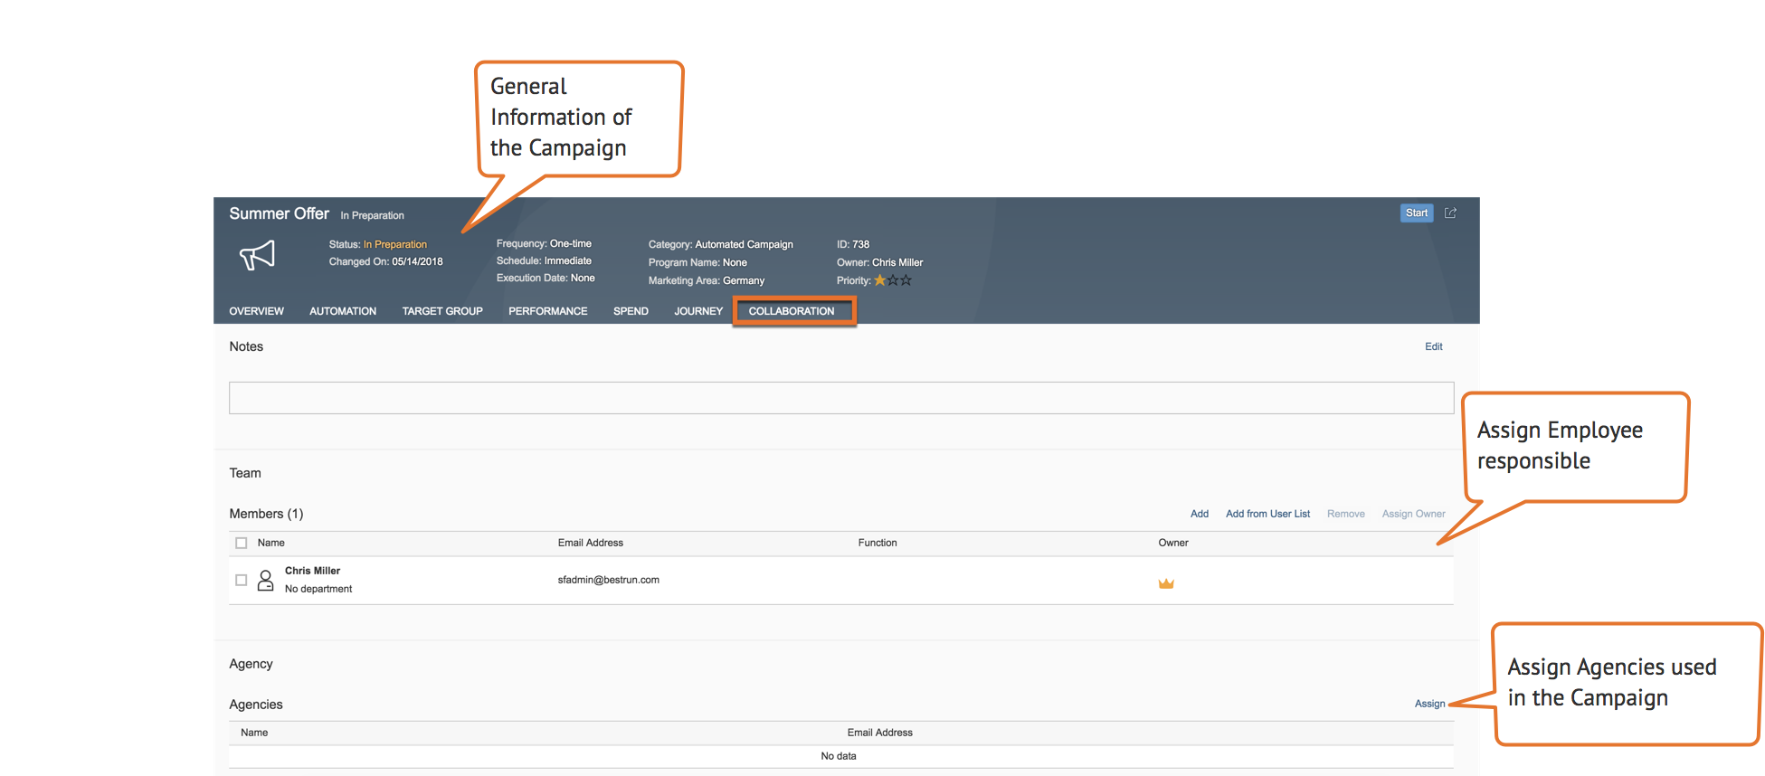
Figure 46: Assign of Team members and Agencies will be available in the Collaboration Facet

Suppression Rules
The Suppression Rules will allow users to set up conditions to exclude specific Contacts who meet the criteria of automatic suppression. BP exclusion occurs regardless if they met the criteria in the segmentation builder: excluding contacts that are in geographically sensitive areas such as hot zones which may have a negative reaction to the communication. These rules are checked every time a campaign is executed.

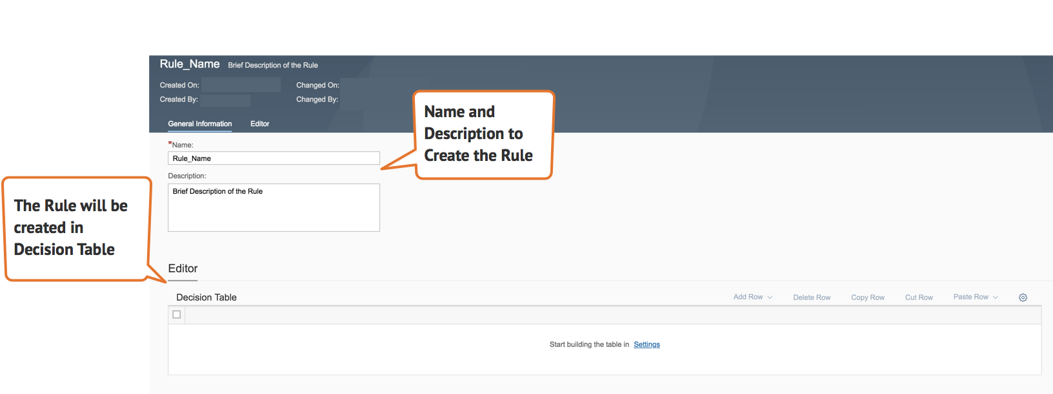
Figure 47. – Suppression Rule application view

Marketing Lead Management
Lead Management is associated with the Marketing and Sales area. Lead readiness is generated for the Sales Department via SAP Marketing Cloud. SAP Marketing Cloud has the ability to manage and nurture the Leads to ensure that conversion to viable projects are successful and will sustain throughout completion of the SCE Sales Cycle. The leads and Opportunities managed in SAP C4C are documented in CIM-CS-16 - Manage Leads, Opportunities & Territory.

The nurture process takes place in the SAP Marketing Cloud with the objective to have a better knowledge and understanding of the leads being generated in the system.

In SAP Marketing Cloud, the lead management process starts with the designated Contacts that are indicated to have an intent and interest to participate or enroll in a Product and/or Program.

From a SAP Marketing Cloud perspective, the Lead Management process includes the following steps:

- Transfer of leads based on qualified Contacts to an SAP C4C system by a campaign with a category for lead creation, leads are then replicated to SAP C4C. Leads are created in SAP C4C with the associated Contact details.
- Processing of leads in SAP C4C, and replication of lead, opportunity, and Contact data back into SAP Marketing Cloud. If the lead is updated in C4C then the corresponding update will occur in SAP Marketing Cloud.

Marketing Lead Transfer To SAP C4C

The creation of leads in SAP C4C Sales will be handled by creating campaigns with a lead-focused category, a corresponding action, and a specific target group assigned. The target group includes the Contacts that have reached lead readiness.
In regularly scheduled execution runs for a corresponding campaign, the system transfers target group members as leads to SAP C4C. After an initial execution run, the system excludes all target group members that were previously passed to SAP C4C as leads.

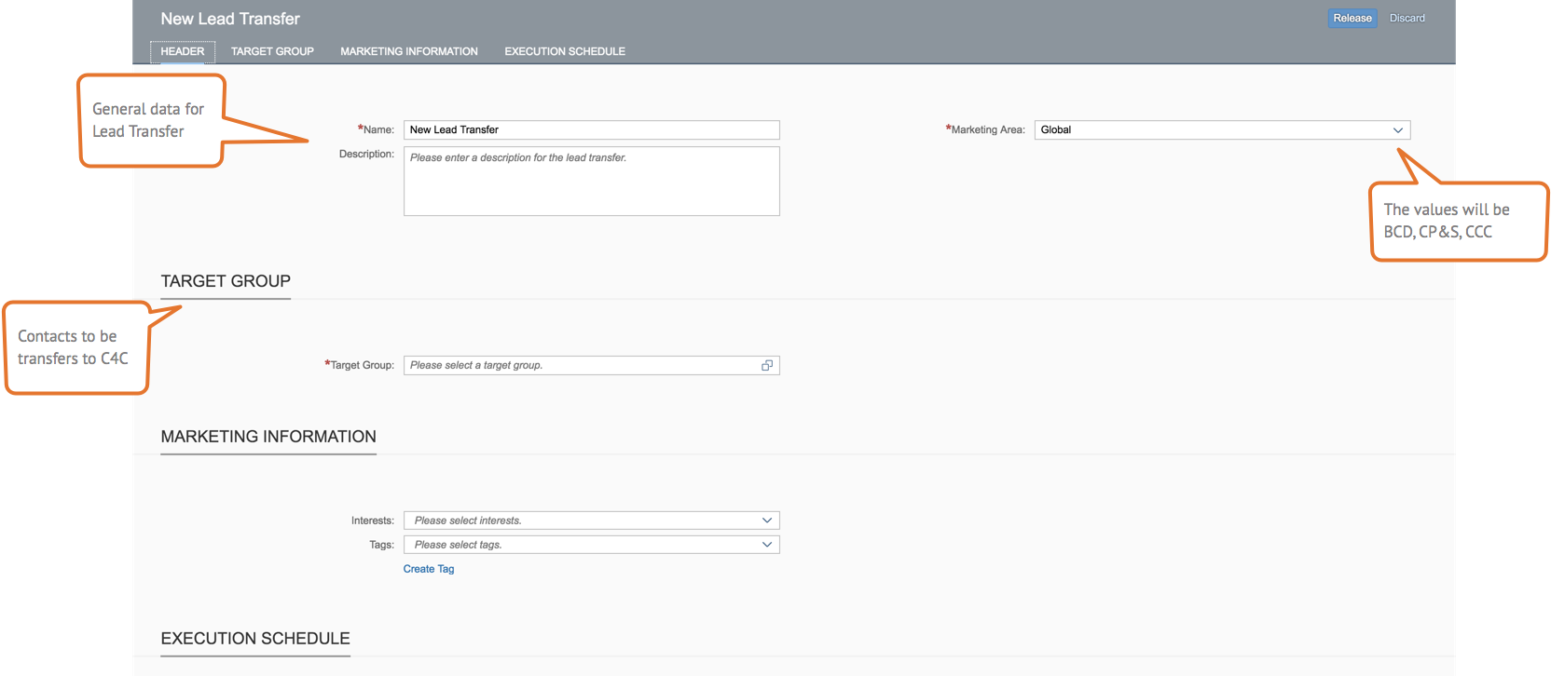

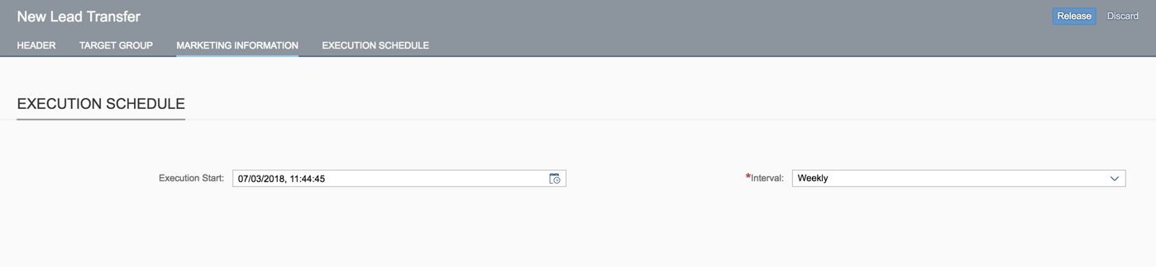
Figure 49. – Lead Transfer application view.

Analytics
With SAP Marketing Cloud, the analytics will provide users the ability to analyze campaign results with two options: Standard Reports from SAP Analytics Cloud and SAP Marketing Cloud.

Analytics in SAP Marketing Cloud

The analytics capabilities of SAP Marketing Cloud will allow users to perform their operational day to day reports.
The following queries will be used to slice and dice at the campaign response information:
- Campaign Success for Messages - C_MKT_CAMPAIGNSUCCESSQ
- Campaign Performance - C_MKT_AGGRGDCMPGNSUCCESSQ
- Aggregated Campaign Success Email - C_MKT_AGGRGDCMPGNSUCCEMLQ
- Leads and Opportunities for Dashboard - C_MKT_LEADSOPPS_BOCQ

Refer to Figure 50 for available user actions within the query browser:
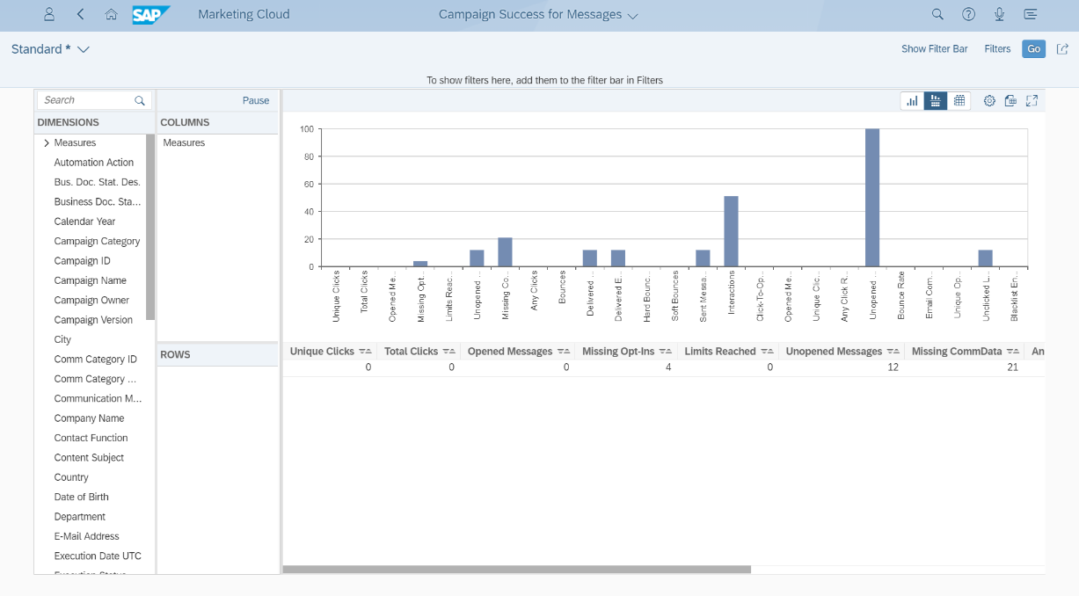
Figure 50. – Analytics application view

For links contained in the email campaigns, just one report being possible to slice and dice to the link level, knowing how many clicks per link as it can be seen in the Figure 51 below:
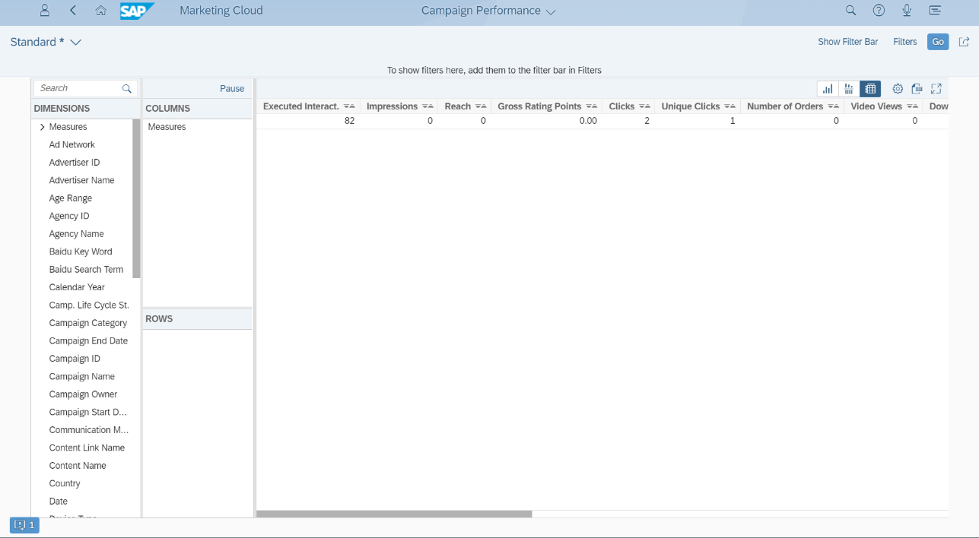
Figure 51: Report View

In the standard Campaign Success report can be selected the parameters: Interaction type, Name and Campaign ID in order to get the overview of the Contacts whom has Hard and Soft Bounces for a certain campaign as is depicted in the following figure 52:

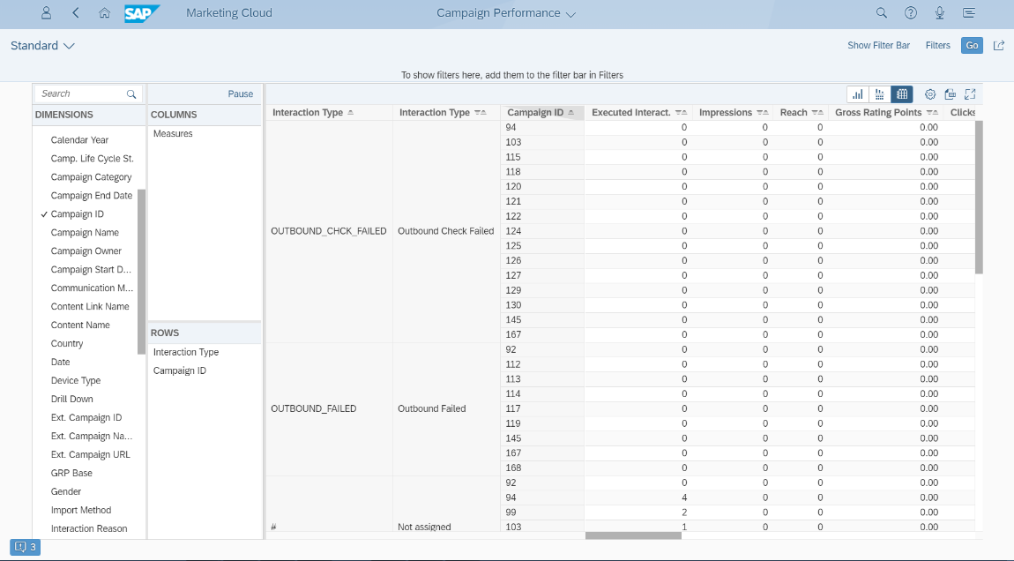
Figure 52: Report that displays Contacts with Hard and Bounce per Campaign ID as an example.

SAP Analytics Cloud

SAP Analytics Cloud provides insights from the data sources indicated in this document (SAP C4C). With SAP Analytics Cloud, users can leverage agile reports such as ‘click to open rate’ versus ‘opened’ and ‘delivered’ messages that can easily be adapted to individual needs. NOTE: Analytics Cloud will not be available at implementation, but at a later release.
This solution provides users with flexible and attractive visualizations. Stories are customized by business role. The following reports (known in SAP Analytic Cloud as Stories) will be used to cover SCE requirements:
- Story on Campaign Success for Messages
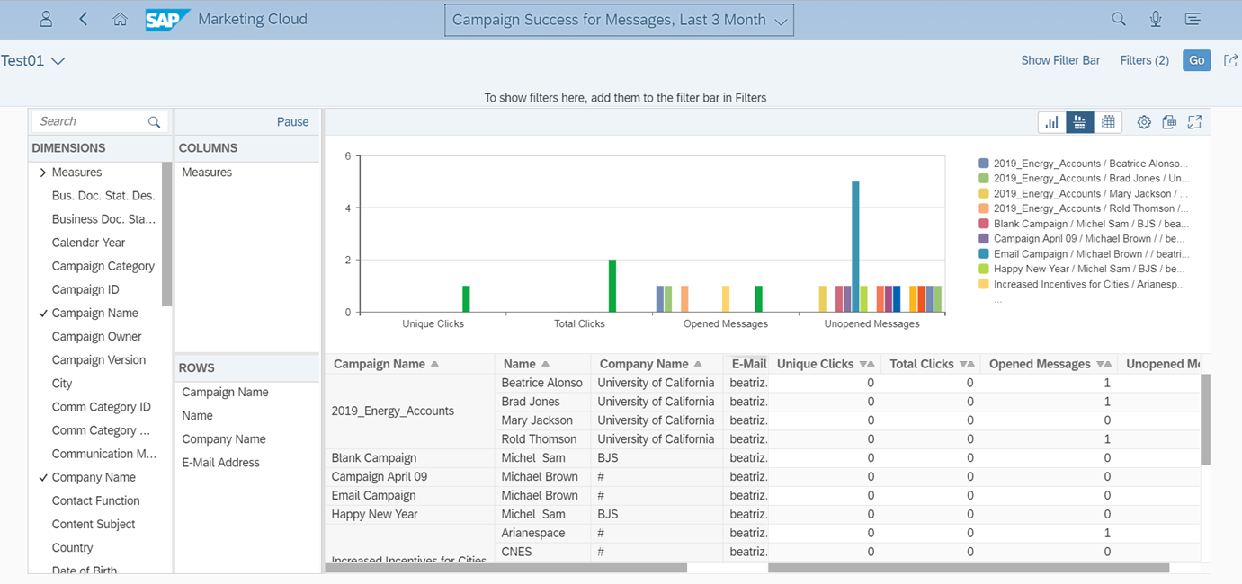
Figure 53. – Report for Campaign Success

- Story Lead Management
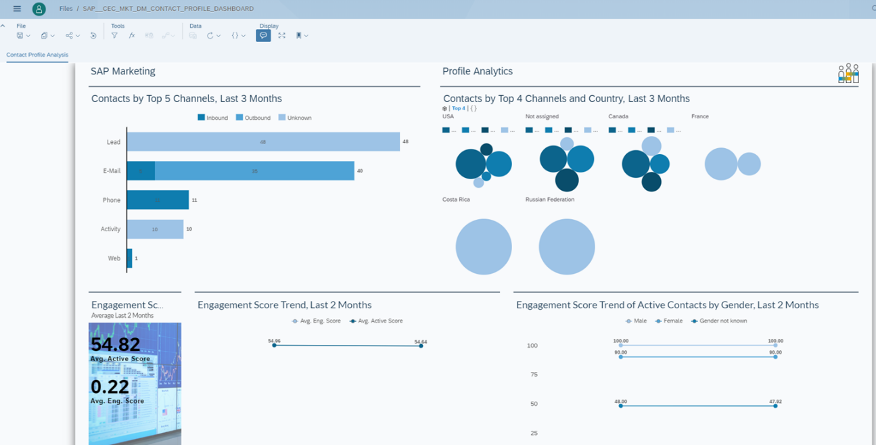
Figure 54. – Report for Lead Management

Process / Performance Improvement
- Insights and dynamic 360-degree contact profiles indicated in the section 2.2 of this document will be provided for more contextual, customized experiences by gathering data from the system sources defined.
- Real time segmentation tool.
- Execution of Omni-channel campaigns and trigger automatic follow-up actions (campaign automation).
- Create personalized campaigns and the ability to manage content for campaign execution.
- User clickstreams, events (email opening, opt-in / opt-out), and interactions are also sent to SAP Analytics Cloud in real-time.
- Out-of-the box Reports of Campaign results.

Prerequisites and Inputs
Contact Profiling
- Integration and data load with relevant source systems detailed in the section 2.12 of this document.
Segmentation
- The Contacts should have values for the attributes defined in the section 2.3 Segmentation in order to filter and create a segment.
- Address data should exist per Contact to perform a Geo-segmentation.
Content Studio
- The Contacts should have values for the attributes defined in the section 2.4 Content Studio to display a value within a dynamic attribute
Campaign execution:
- Integration with Nuance has to be done and finished for Email and SMS Campaigns.
- Integration with SAP C4C for Lead Campaigns.
Lead Management
- Integration with SAP C4C is required to transfer leads.

General Assumptions
- Data Cleansing:
Though the SAP Marketing Cloud aggregates customer data, it will not clean it. Since the entire Marketing Cloud is built on predictive analytics based on customer, it is imperative to ensure the data quality is clean prior to loading SAP Marketing Cloud with data.
Clean-up is made in C4C (data source identified for SAP Marketing Cloud)
- The Contents/Templates required for the campaigns will be created by SCE.
- The Business Partner created or updated in C4C is synchronized into SAP Marketing Cloud in real time according the standard integration between both systems. As part of the daily task administration, the integration of these systems is must be manually triggered.
- Preference Center will be created and updated only in S4HANA using UPrefer. In order to preserve data consistency of this information all the updates will be done in S4HANA (source system) and will be replicated to SAP Marketing Cloud. FS 2710 enhances the CPI relationship payload to allow Account Contact email, SMS, phone field. Updates are done manually via BPREL job.
- When a contact opt-outs out of receiving marketing communications via the campaign (e.g., email and SMS), Updates must be done manually in Marketing Cloud to reflect opt-outs.
- If the email sent is not successfully delivered because it is a “Bad Email” (not active), the system will create the Interaction on the Marketing Cloud side while utilizing Enhancement 1180 to remove BP Contact information on the S/4 HANA side upon receiving a ‘hard bounce’.
- If the SMS sent is not successfully delivered because it is a “Bad Phone number” (not active), the system will create the Interaction on the Marketing Cloud side while utilizing Enhancement 1180 to remove BP Contact information on the S/4 HANA side upon receiving a ‘stop all.
- Since Nuance will be the SMS and Email provider it will send the response data (of emails and sums) back to SAP Marketing Cloud for further data analysis, save for hard bounces and STOP which will be sent back to S4 HANA’s UPrefer transaction.

Process Flows

Segmentation and Campaign Management
Process Flow Diagram

Process Flow Steps

Step | Description of Step | Front Office / T-Code | Role(s)
10 | Start | N/A | N/A
20 | Access to the Content Studio to create the Campaign layout based on the SCE Requirements. | SAP Marketing Cloud- Content Studio application | BDC Marketing Agent  CP&S Marketing Agent
30 | Once the layout is finished It can be tested in order to make ensure the design required is correct. | SAP Marketing Cloud- Content Studio application | BDC Marketing Agent  CP&S Marketing Agent
40 | In the Segmentation builder, drag and drop the filter attributes necessary to define the group of contacts to execute the campaign. | SAP Marketing Cloud- Segmentation Builder application | BCD Marketing Agent  CP&S Marketing Agent
50 | Once the segmentation model is defined, generate the Target Group and then, release it to make it available for use in campaign execution. | SAP Marketing Cloud- Segmentation Builder application | BCD Marketing Agent  CP&S Marketing Agent
60 | In the Campaign Application, create the campaign with the information required, template, target group created. | SAP Marketing Cloud- Campaign application | BCD Marketing Agent  CP&S Marketing Agent
70 | When user is finished creating the campaign, the status will be changed to Release to execute the Campaign. | SAP Marketing Cloud- Campaign application | BCD Marketing Agent  CP&S Marketing Agent
80 | Nuance will be the SMS and Email provider to deliver communication messages to the contacts when the Campaign is activated. | Nuance | N/A
90 | The contact receives the Email/SMS Message to the email address defined at contact master data level. | Contact | N/A
100 | Since Nuance is the SMS and Email provider it will Send/Replicate success data back to SAP Marketing Cloud for further data analysis. | Nuance | N/A
120 | The data received back will be displayed in the Success of Campaign Report | SAP Marketing Cloud- Analytics application | BCD Marketing Manager  CP&S Marketing Manager  CSOD Marketing Manager
130 | End.

Marketing Lead Management
Process Flow Diagram

Process Flow Steps

Step | Description of Step | Front Office / T-Code | Role(s)
10 | Start | N/A | N/A
20 | Into the Segmentation builder drag and drop the filter attributes to create a Segment. | SAP Marketing Cloud- Segmentation Builder application | BCD Marketing Agent  CP&S Marketing Agent
30 | Once defined the segmentation model, generate the Target Group and release it. | SAP Marketing Cloud- Segmentation Builder application | BCD Marketing Agent  CP&S Marketing Agent
40 | Into the Campaign Application, create the campaign with the information required, template, target group and insert into the campaign automation the action “Lead” to execute the lead transfer to C4C. | SAP Marketing Cloud- Campaign application | BCD Marketing Agent  CP&S Marketing Agent
50 | Once finished the creation step of the campaign it must be changed for the status Released to execute the campaign. | SAP Marketing Cloud- Campaign application | BCD Marketing Agent  CP&S Marketing Agent
60 | SAP C4C will receive the lead data in order to create the Leads into this system. | SAP C4C | N/A
70 | All the updated executed in SAP C4C for the Leads received will Send/Replicate back to SAP Marketing Cloud for further data analysis. | SAP C4C | N/A
80 | The data received back from SAP C4C (lead updates) will be display in the Report of Success of Campaign | SAP Marketing Cloud- Analytics application | BCD Marketing Manager  CP&S Marketing Manager  CSOD Marketing Manager
90 | End.

3rd Party and SCE Legacy System Integrations

3rd Party or SCE Legacy System Integration | Description of Integration and Required Change to 3rd Party or SCE Legacy System | Estimated Complexity of 3rd Party or SCE Legacy system change
SAP S4 HANA | Integration and Initial load of:  - Customer Master Data  - Contact Master Data | TBD
SAP C4C - Sales | Integration and Initial load of:  - Activities  - Leads  - Opportunities  - Marketing Attributes (Business Attributes)  - Segment ID (Custom field) | TBD
Nuance | Email and SMS Provider | TBD

Data Elements
The information that will be captured for the Content Studio and Campaigns will be defined in this section of the BPD. Contacts, Segmentation, Marketing Lead Management and Reports do not apply.

- Content Studio
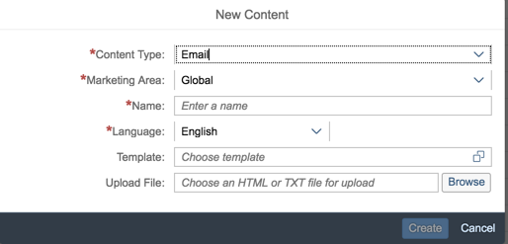

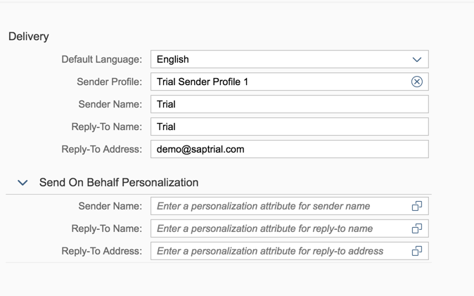

Field | Type | Comments
Content data
Content Type | Required | Input Field
Marketing Area | Required | Input Field
Name | Required | Input Field
Language | Required | Input Field with Dropdown List
Template | Optional | Input Field with Standard Search Help
Upload file | Optional | Input Field with Standard Search Help
Delivery
Default language | Optional | Input Field with Dropdown List
Sender Profile | Required | Input Field
Sender Name | Required | Input Field
Reply-To Name | Required | Input Field
Reply-To Address | Required | Input Field
Send On Behalf Personalization
Sender Name | Optional | Input Field
Reply-To Name | Optional | Input Field
Reply-To Address | Optional | Input Field

- Campaign Management
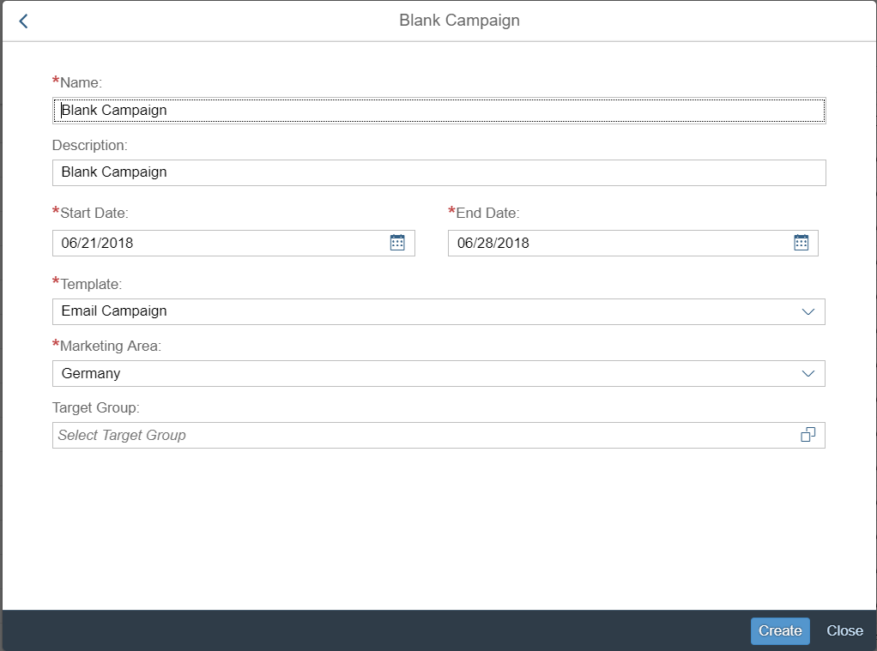
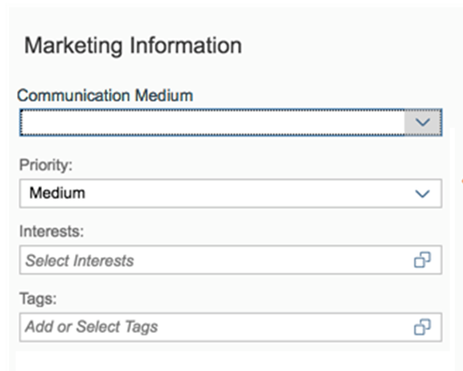
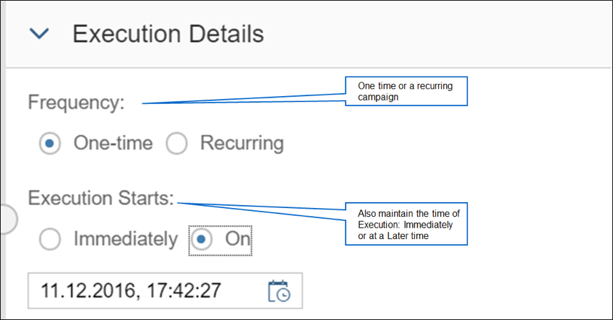



Field | Type | Comments
Campaign data
Name | Required | Input Field
Description | Required | Input Field
Start Date | Required | Input Field with Standard Search Help
End Date | Required | Input Field with Standard Search Help
Template | Required | Input Field with Dropdown List
Marketing Area | Required | Input Field with Dropdown List
Target Group | Optional | Input Field with Standard Search Help
Communication Medium | Required | Input Field with Dropdown List
Priority | Optional | Input Field with Dropdown List
Interests | Optional | Input Field
Frequency | Optional | Check box
Execution Starts | Optional | Check box
Collaboration
Notes | Optional | Text field
Team member | Optional | Input Field with Standard Search Help
Agencies | Optional | Input Field with Standard Search Help

Source Systems and Data Volumes
Source: S4HANA
The number of Business Partner and business transactions processed in S4HANA annually are specified below: Approximately 37,000,000

SAP Marketing Cloud Integration

Processes
- SAP C4C Sales
For SCE the leads activities and opportunities created in SAP C4C Sales will be replicated to SAP Marketing Cloud as is can be seen is the following diagram:

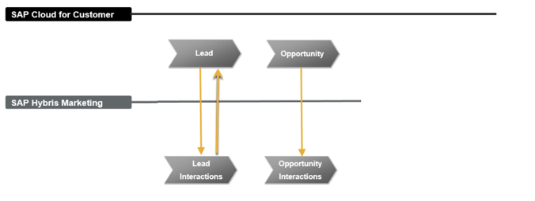

SAP Marketing Cloud Views
- Quick launch
- Contacts and Profiles
- Segmentation
- Content
- Campaign Management
- Lead Management
- Marketing Data
- Import Data

Exception Management Requirements
User Exception Scenario / Description | User Group | Initiated by | Work Distribution
N/A | N/A | N/A | N/A

Process Risks and Mitigation
- Replication issues between SAP Marketing Cloud and SAP C4C/S4HANA
  - Mitigation: monitoring of data replication should be performed as part of the system support.
- Email throttling when an email campaign is executed
  - Mitigation: as Nuance will deliver the corresponding SMS and Email message to the contact by evaluating the message’s priority. Lower priority messages will be sent out after all higher priority messages have been sent.
- Some of the Business Users don’t use the system to create the SCE Campaigns causing data inconsistency in the Reports of the campaign executed or planned in a certain period of time.
  - Mitigation: implement change management strategies and follow up to the business users.
- Customer marketing and communication opt-outs via the campaign will be automatically updated in S/4HANA via UPrefer.
- When emails and SMS are not successfully deliverd because the phone or email is bad “not active” it will be automatically updated in S/4HANA. If not done correctly and timely, it could result in future unnecessary communications costs when sending communications to the bad phones or emails (all types of digital communications).
- If we do not correctly delete a bad phone from the marketing campaign send result in a timely fashion, the phone could be reassigned to another party within 90 days or sooner of it being disconnected. This could result in SCE sending communications to the wrong party (TCPA non-compliance).

Key Performance Indicators
The following have been identified as KPI’s at Southern California Edison, along with the means of measuring each KPI and the current measurement statistic for each KPI:
Measured KPI | Description | Measurement Method | Current Statistic
N/A | N/A | N/A | N/A

Key Metric Definition
The following have been identified as key metrics at Southern California Edison that require business rule for calculation:
Key Metric | Description | Business Rule | Reference
N/A | N/A | N/A | N/A

Controls, Regulatory Rules, and Security
Requirement  ID (from RTM) | “As-Is” Control Requirement | “To Be” Risk Statement | “To-Be” Control Activity” | Control Automation (manual, IT dependent- manual, automated, SOD, Sensitive Access) | Relevant technical identifier or RICEFW reference

Security Considerations
Role | Transaction Code (T-Code) / Work center -> View Name | T-Code Description/ View Description | Authorization Attributes | SOD Conflicts (Yes/No)  If SOD Conflicts Yes. Identify the 2 conflicting t-codes
BCD/CP&S  /CSOD Marketing Agent | Business Groups/Workcenters:  - Quick launch  - Contacts and Profiles  - Segmentation  - Content  - Campaign Management  - Lead Management  - Marketing Data  - Import Data  - Analytics | a) Contacts and Profile:  - Contacts and Profiles  - Profile Dashboard  - Profiles  - Sentiment Engagement  - Contacts  - Customer Journey Insight  - Score Builder  - Predictive Studio  - Profile Dashboard  b) Segmentation  -Segmentation Model  - Segmentation Building Blocks  -Target Groups  c) Content  - Content Studio  d) Campaign Management  - Campaign  - Lead Management  - Transfer Leads  - Score Builder  - Lead Dashboard  e) Marketing Data  - Marketing Agencies  f) Import Data  - Import Data  - Suppression rules | N/A | N/A
BCD Marketing Manager | Analytics | Reports | N/A | N/A
CP&S Marketing Manager | Analytics | Reports | N/A | N/A
CSOD Marketing Manager | Analytics | Reports | N/A | N/A

Custom Program/Transaction Codes
Please identify any custom programs/transaction codes that need to be developed for RICEFW objects.

Custom Program | Authorization Grp | Custom T-code | Authorization Object used in the authorization check statement
NA | NA | NA | NA

Custom Table/Transaction Codes
Please identify any custom tables/transaction codes that need to be developed for RICEFW objects.

Custom Table | Authorization Grp Assigned | Custom T-code for the Table | Table Access (display/update)
NA | NA | NA | NA

Data Criticality and Cybersecurity Baseline Risks
Specify Data Classification /Special Handling or Regulatory Requirement  What is the classification of Data? Does it trigger any special regulations?  Please select the classification / Sensitivity of the Data. This will help us Assess the Risk associated and remediation measures if any. | <Select all that apply>  ☒ PII - Personal Identifiable Information / Privacy Law  ☐ CEII - Critical Energy Infrastructure Information  ☐ FERC SOC (Standards of Conduct)  ☐ NERC CIP Confidential  ☐ Sarbanes-Oxley (SOX) financial reporting data  ☐ SCE utility data accessible by affiliate companies (CPUC)  ☐ PCI - Payment Card Industry Compliance  ☐ Customer Information Service Request (CISR, CISR-DRP)  ☐ Other _<Please Specify>_  ☒ Internal  ☒ Public  ☒ Confidential
Please identify which business Group/Role will require access to the data and/or solution:  Please select the list of Busines Groups will have access to this Data / Process. This will help us Determine the Impact and Risk Spread. Will ensure efficient Risk mitigation measures. | <Select all that apply>  ☐ SCE Customer, Res./Comm. Customer;  ☒ SCE OU, Business Function Organization Name: CCC, BCD, CP&S  ☐ Vendor  ☐ External business partner(s) & SaaS providers  ☒ External on-shore contractors  ☐ External off-shore contractors  ☐ SCE Affiliate Company Employees  ☒ SCE Employees, specify if they have Marketing Function responsibilities (e.g., ES&M)  ☒ SCE contract workers  ☐ Regulatory Agencies  ☐ Others _<Please Specify>_
How many of the SCE Customer, Employee, Vendors will use or affected by the Business Process?  To identify the Impact if services are adversely affected. | 10,000+…..  <100
How much Information/data would be processed, received or tramitted by the Business Process?  The data volume that will be utilized by this process. Helps us in determining the Impact and criticality | 10,000+ MB / GB…..
Number of business transactions in average?  These are the number of transactions process by the application on average. The number of transactions help in understanding criticality and Impact. | Need number of transactions we do today.
Additional Security Consideration: | Any Cybersecurity impact in addition to SAP system security:  - Internet Facing Web Application? Yes/No, Details: Yes on SCE.COM  - Internet Facing Application Programming Interface? Yes  - 3rd party Fedrated Authentication & Authorization, Single Sign On? Yes

Technical Considerations

4.1 RICEF-W Assessment
All of the Forms, Reports, Interfaces, Conversion items, Extensions/Enhancements and Workflows (RICEF-W) that have been identified for this BPD are detailed in the tables below and will represent the totality of all RICEF-W items documented at the time of sign-off of this BPD. Any RICEF-W items that are confirmed via change control after this BPD receives final sign-off, will be managed within Southern California Edison’s APSE environment and not within this document.

Reports
Report Name & Description (List Requirements met by this Report) | Complexity | Reference ID
NA

Interfaces
Interface Name & Description (List Requirements met by this Interface) | Complexity | Reference ID
Nuance Interface | Complex | 2066
Inferface to replicate the contacts Preference Center from S4HANA to SAP Marketing Cloud. | Complex | 2065

Conversion
Conversion Name & Description (List Requirements met by this Conversion) | Complexity | Reference ID
N/A

Extension/Enhancements
Extension Name & Description (List Requirements met by this Extension) | Complexity | Reference ID
Enhancement to replicate the Segment ID from C4C Sales to SAP Marketing Cloud. The Segment ID is a custom field in C4C. | Complex | 2064

Forms
Form Name & Description (List Requirements met by this Form) | Complexity | Reference ID
NA

Workflows
Workflow Name & Description (List Requirements met by this Workflow) | Complexity | Reference ID
NA | N/A | N/A

IDEX Considerations
N/A

Production System Cut-over Considerations
- Integration with SAP S4HANA Production system and replicate Business Partners to SAP Marketing Cloud
- Integration with SAP C4C Productive Tenant and and replicate Leads, Opportunities, Activities to SAP Marketing Cloud
- Integration of SAP Marketing Cloud Productive tenant with Email and SMS Provider

4.4 Other Considerations
N/A

Change Management

5.1 Change Impacts
Change Element Short Description | Change Impact Category | Audience Group(s) | Impact | Business Effort
In SAP, agents will have the ability to remove customers from receiving marketing campaigns using customer preferences. Currently agents do not have the ability to stop postal marketing campaigns. The new process provides customers more flexibility to choose from different campaign types as well as provide first call resolution. | Process; Regulatory/Legal; Improvement (446) | CS-CSOD-CCC All; CS-CSOD-Consumer Affairs | Low | Low
Duplicate listings will be reduced because SAP will have 1 integrated system that can be used for market segmentation/target lists using different parameters such as tariffs, geo locations, usage, meter type, NEM/PEV, delivery channel preference etc. Currently we use multiple systems or data sources (e.g. CSS, Legacy CRM, third party listings etc.) to gather customer information for creation of target lists. | Process;Technology;Improvement (447) | CS-CP&S-All; CS-BCD-All | High | High
In SAP, target lists can be created using BI objects, as well as in the campaign function which will save in processing time and the lists can be re-used for other campaigns. Once the target list is created, it can be saved. Currently campaign lists come from multiple sources including Legacy CRM and must be re-created for each campaign. The new process will allow BCD account managers to create their target list based on their assigned territory without re-creating. | Process; Culture Shift; Decision Making; Improvement (451) | CS-BCD-All; CS-CP&S-All | Medium | Low
Analytics will be available to view and analyze campaign results which can be pulled and analyzed internally and we will no longer need to use a 3rd party to gather and present the results. This can be used with 2 options: standard reports from SAP analytics cloud and SAP Marketing Cloud. Analytics can be used to learn from for future campaign efforts. | Process; Decision Making; Improvement (452) | CS-BCD-All; CS-CP&S-All | Medium | Medium
Front office will have the ability to view the campaign through a SAP Marketing Cloud mash up in C4C so that they can see what was sent to the customer including the actual communication (e.g. letters, email, text etc.). This capability will increase customer satisfaction since the agent will have visibility to the campaign and can respond to customer inquiries as part of first call resolution. Currently the CCC relies on communications and Portal to learn about campaigns sent to the customer including copies of the letter. | Decision Making;Process;Culture Shift; Improvement (453) | CS-CSOD-CCC All; CS-CSOD-Consumer Affairs | Medium | Medium
Business Customer Division (BCD) will have the ability to create and analyze US mail campaign. This allows for differentiation of campaign types. Currently BCD has to create a documentation campaign since the mail campaign is currently not in Legacy CRM. | Process; Improvement (454) | CS-BCD-All | High | High
BCD & CP&S will utilize the same standardized campaign types (e.g.., Promotional, Transactional, Internal Campaigns etc.). There will be uniformity in the campaign types allowing for comprehensive reporting on marketing campaigns. Currently each group has different types based on their campaign. | Process; Improvement (455) | CS-BCD-All; CS-CP&S-All | Low | Low
Pending solution - Campaigns sent out via a third party vendor (e.g. Sales Force, Open Text) will be stored in Open Text or SAP Marketing Cloud. Currently emails sent are not stored in centralized depository for users to see. This process will allow front end users to view email correspondences sent out via marketing team. Depending on the solution, the process may be a manual upload in Open Text or SAP Marketing Cloud  Operational Impact: This would be a new task for the marketing team in CP&S if a manual upload is required. Also depending on the size of the marketing audience, it may be a system strain on the uploading of the document.  Customer impact: Indirect impact - Front end users have the ability to view the emails and can discuss with the customer instead of looking for a copy of the email or having the customer read the email to the agent. | Improvement; Job Roles (Neutral);Culture Shift; Process; Staffing Levels (1080) | CS-BCD-All;CS-CP&S-All;CS-CSOD-CCC All; CS-CSOD-Consumer Affairs | Medium | Medium
In the SAP Marketing Cloud system, a customer/business partner is known as a Contact. Interactions are transactions (sales orders, activities, leads and opportunities) that are created in SAP Marketing Cloud. These terms have different meaning or different equivalents when it comes to other systems such as C4C or S4/HANA. Users will need to understand that meanings based on the system they will be working with. | Process (1155) | CS-BCD-All;CS-CP&S-All;CS-CSOD-CCC All; CS-CSOD-GC Services | Low | Low
Users that have access to SAP Marketing Cloud as well as other SAP systems may have multiple sign ons. It will be a separate URL link that will not be accessible through C4C. Users will need to save as a Favorite in their browser to access a quick link. | Process (1156) | CS-BCD-All | Low | Low
Each contact will have a classification based on data source of the contact. There are 3 types (self-identified, verified, and business partner). These are new types associated with SAP Marketing Cloud and there are no current contact types today. This will be new classifications. | Decision Making; Process (1157) | CS-BCD-All;CS-CP&S-All;CS-CSOD-CCC All | Medium | Medium
In SAP Marketing Cloud, the campaign will go through multiple statuses for the lifecycle of the campaign. Users will need to know and understand the different statuses of the campaign. New statuses include: In preparation, released, stopped, and discarded | Decision Making; Process (1159) | CS-All;CS-CP&S-All;CS-CSOD-CCC All | Medium | Medium
Within SAP Marketing Cloud, the sentiment engagement application will provide users an overview of how engaged a contact is based on social media history. The contact's data will be collected and stored within SAP Marketing Cloud. This will allow a sales users the ability to determine engagement scores of the contact. This is new functionality that is currently not available within Legacy CRM. | Improvement; Decision Making; Process; Technology; Job Roles (Positive) – (1161) | CS-BCD-All; CS-CP&S-All | High | Medium
Content studio is a standard tool that will allow users to create the layouts for campaigns. The campaign will go out directly from the system. Currently email campaigns are created within Legacy CRM but the email is sent out through a different system (e.g. Outlook). | Improvement; Culture Shift; Decision Making; Process; Technology (1162) | CS-BCD-All; CS-CP&S-All | Medium | Medium
Automatic responses that are received for campaigns created from SAP Marketing Cloud (e.g. hard bounce backs, opt outs, bad phone numbers etc.) will be stored and housed in SAP Marketing Cloud system but will not be updated in S4/HANA. A user will need to create a report and manually update the contact information in the preference center. This would be a new manual process for a group to handle. | Job Roles (Neutral);Staffing Levels; Process (1163) | CS-BCD-All; CS-CP&S-All | Medium | Medium

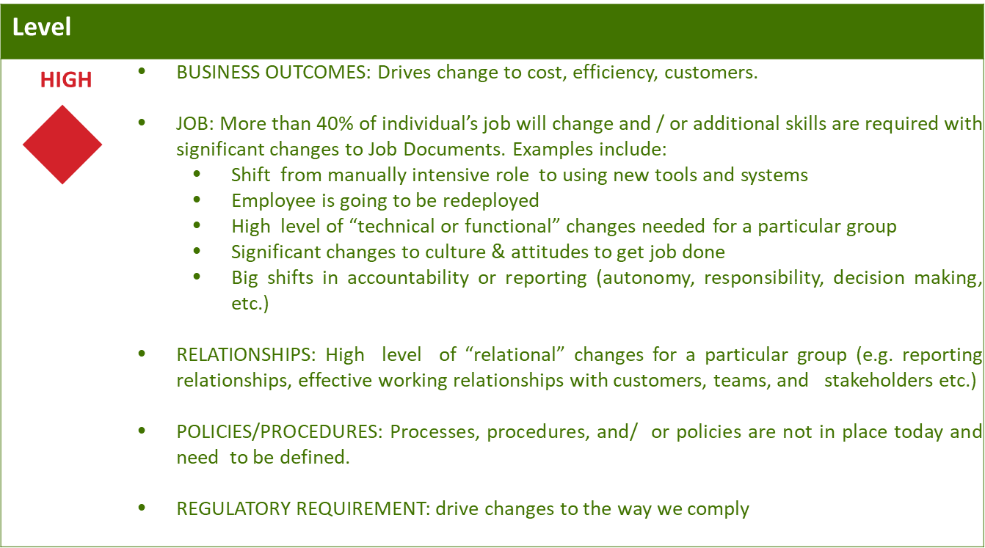
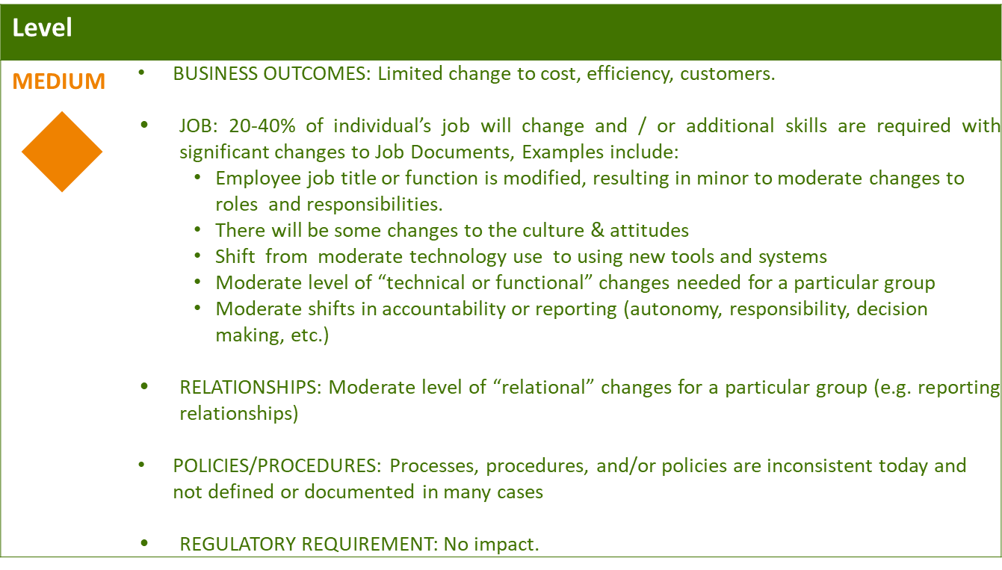
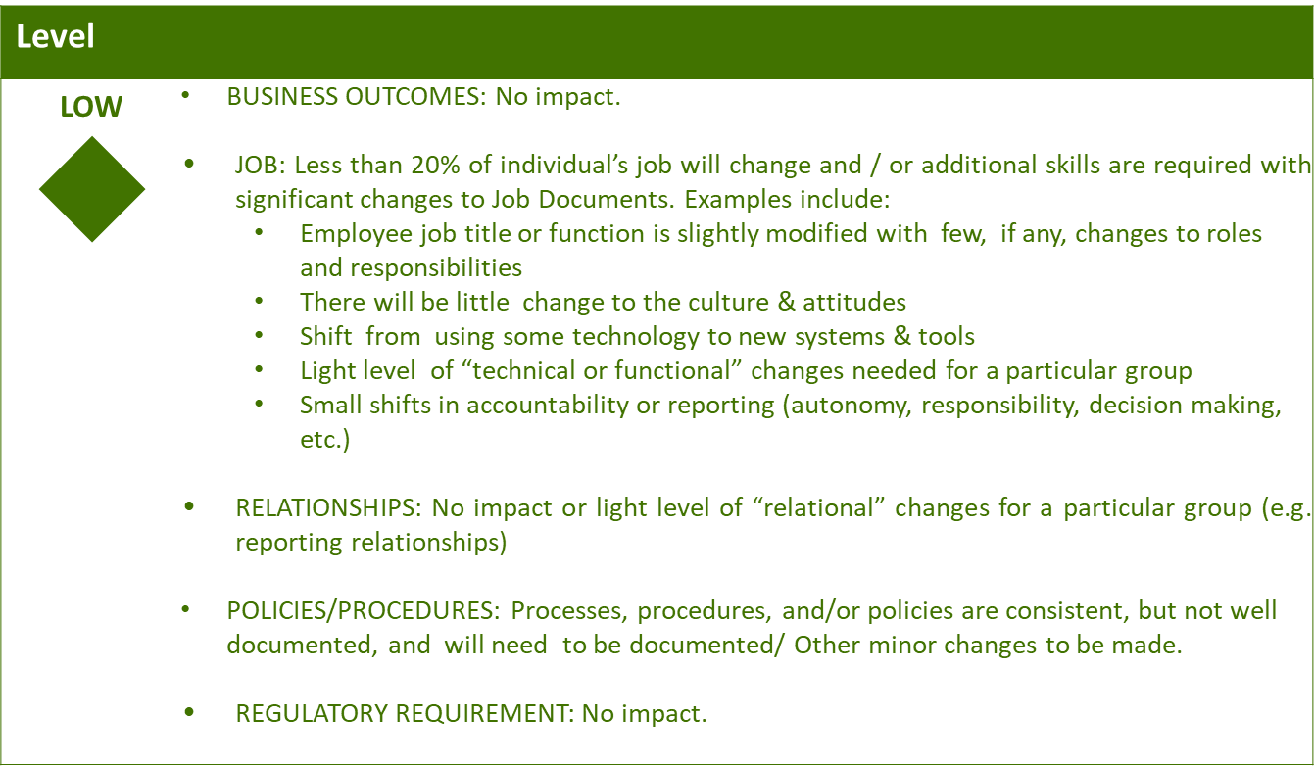

Business Effort: Initial assessment of the impact to the business High, Medium, Low

Requirements

Interaction recording, and all reporting functionalities that utilize interaction data, will not be functional until post Go-Live.
Spotlighting Accounts searches for the Account (Organization BP) specifically. The relationship payload contains the contact fields for the Contact associated with the account through relationship type BUR001 (Contact Person).
Post-Go Live activity.
Full interactions will be viewable after Go-Live.
Functionality will be available Post Go-Live.
Functionality will be available Post Go-Live.
Functionality will be available Post Go-Live
Geolocation will be fully functional when the premise is incorporated in SAP Marketing Cloud. As for now, SAP Marketing Cloud only replicates from the BP which makes the Geolocation unavailable at this time.
Functionality will be available Post Go-Live.
Functionality will be available Post Go-Live.
Functionality will be manual until Post Go-Live.
This interaction data is received as an asynchronous communication using a web beacon.
Functionality will be available Post Go-Live.
Functionality will be available Post Go-Live.
Full functionality of this capability will be available after Go-Live.
Full functionality of this capability will be available after Go-Live as per SCC 730.
Functionality will be available post Go-Live.
Asynchronous communications are ensured by including the custom attribute ‘BP ID’.

